Nelson Gregoire Sr.

June 13, 1928 – October 8, 2001

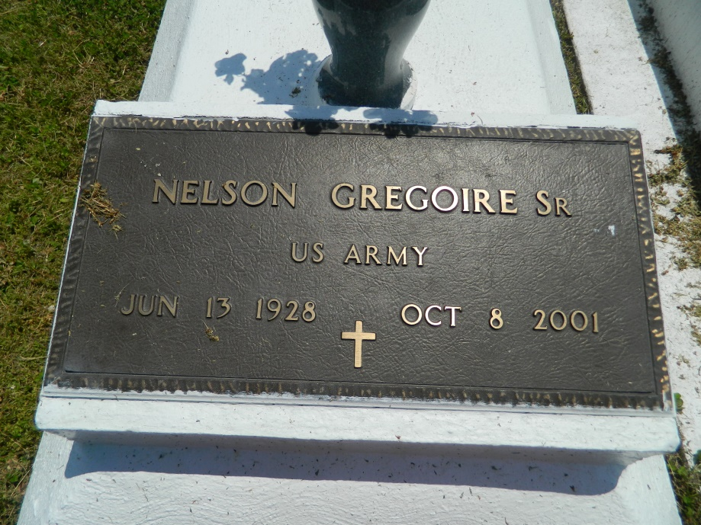

Nelson Gregoire Sr., a retired skycap for New Orleans International Airport, died Monday of heart failure at Kenner Regional Medical Center. He was 73. Mr. Gregoire was born in St. James and lived in Kenner for the past 33 years. He was a member of St. Michael Baptist Church, where he served on Usher Board No. 1. Survivors include two sons, Frederick and Nelson Gregoire Jr.; four daughters, Gwendolyn G. Lee, Deborah Webb, Opal and Denise Gregoire; a stepson, Edward Brown; a brother, Charles Gregoire; two sisters, Oneda Joseph and Geneva Stemley; 11 grandchildren; and 18 great-grandchildren. A funeral will be held Saturday at 11 a.m. at St. Michael Baptist Church, 315 James St., Kenner. Burial will be in Providence Rest Haven Cemetery in LaPlace. Richardson Funeral Home is in charge of arrangements.

Times-Picayune, The (New Orleans, LA) - Friday, October 12, 2001

Contributed by Jane Edson

\*\*\*\*\*

KENNER - Nelson Gregoire Sr., 73, a native of St. James and resident of Kenner for 33 years, died Oct. 8. He was the father of Gwendolyn Lee, Deborah Webb and Opal, Denise, Fredrick and Nelson Gregoire Jr. and stepfather of Edward Brown. He was the brother of Oneda Joseph, Geneva Stempley and Charles Gregoire. He is survived by 11 grandchildren and 18 greatgrandchildren. He was a retired skycap with New Orleans International Airport. Services are today at 11 a.m. at St. Michael Missionary Baptist Church, Kenner, with interment at Providence Resthaven Cemetery, LaPlace. Visitation starts at 10 a.m.

L'Observateur, LaPlace, LA; October 13, 2001

Submitted for the LA GenWeb Archives by: Donald W. Johnson