Cynthia (Duhe) Johnson

September 12, 1941 – December 4, 2002

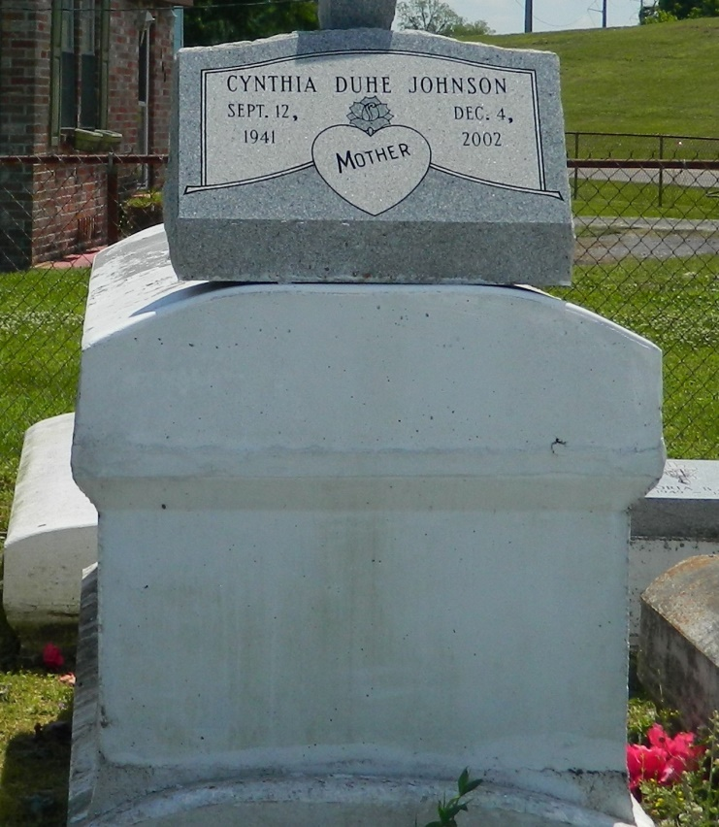

Cynthia Johnson at her residence in LaPlace, LA on Wednesday, December 4, 2002. Daughter of the late Gilbert Duhe and Josephine Smith. Wife of Larry Johnson. Mother of Bernisha Warren, Melissa Robinson and Laticsha Johnson. Sister of Brannetter James, Deloris Breaux, Junious Greene, Edwin Sr., Lawrence Sr. and Gilbert Duhe, the late Ivory Smith and Margarite Lennix. Mother-in-law of Terry Warren, Rodney Dennis and Ernest Robinson. Grandmother of Trey and Terry Warren, Jr., LaMon Robinson, Mone't and Jaunta Johnson. Also survived by a host of nieces, nephews, other relatives and friends. Age 61 years. A native and resident of LaPlace, LA.  
  
Relatives and friends of the family; also priest and parishioners of Our Lady of Grace Catholic Church and all neighboring churches; members of St. Catherine Court No. 73, Ladies Auxiliary/Knights of Peter Claver; employes of Hertz Rent A Car, New Orleans International Airport and East St. John High School are invited to attend the Mass of Christian Burial at Our Lady of Grace Catholic Church, 772 Highway 44, Reserve, LA on Monday, December 9, 2002 at 11:00 a.m Father John Hardman, SSJ - celebrant. Interment Providence Resthaven Cemetery, LaPlace, LA. Visitation at the Church from 9:00 a.m. until Mass time.  
  
SERVICED BY ROBOTTOM.

Times-Picayune, The (New Orleans, LA) - Sunday, December 8, 2002

Contributed by Jane Edson