Darryl Johnson, Jr.

January 28, 1989 – June 12, 2006

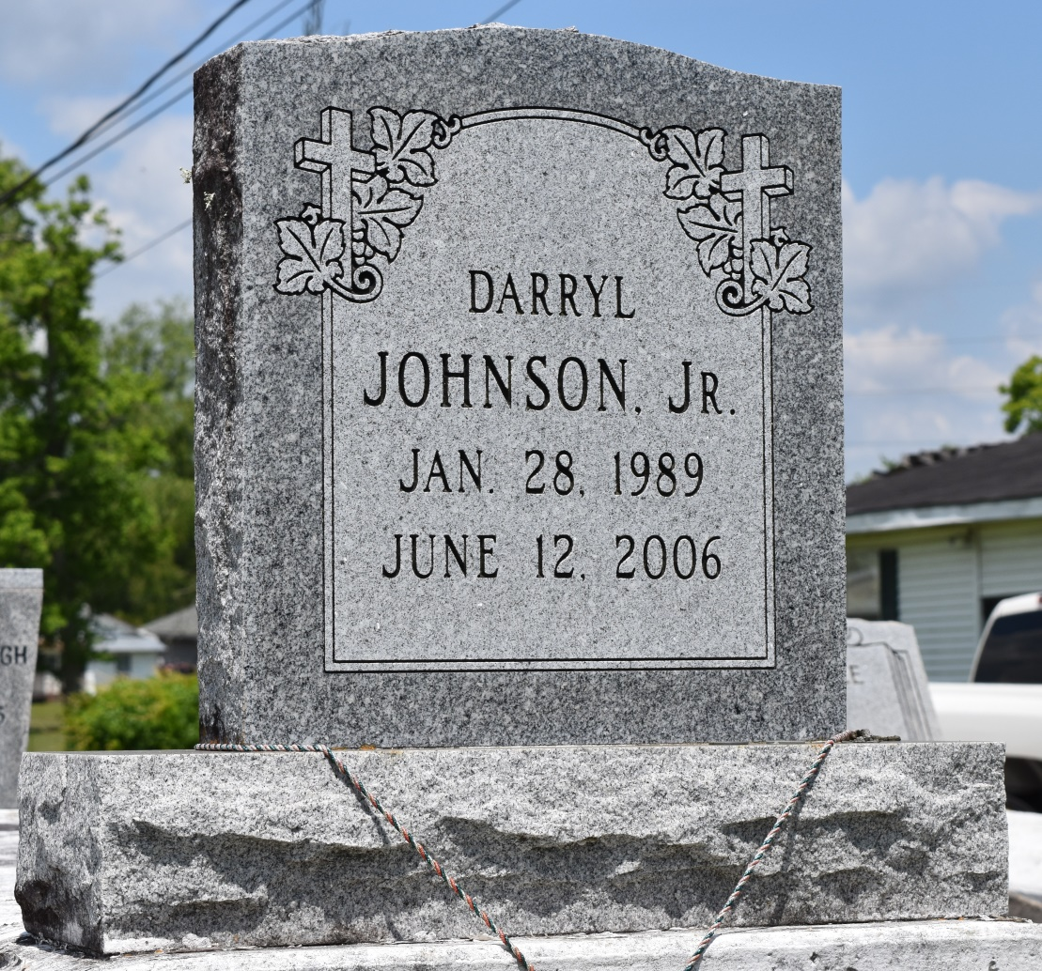

Darryl Johnson, Jr., a student, departed this life on Monday, June 12, 2006 in LaPlace, LA. Son of Darryl and Wendy (Lakhan) Johnson, Sr. Brother of Dylan K. Johnson. Also survived by his grandparents, Winston and Mary Lakhan and Izola B. Johnson; great-grandmothers: Pearl Lakhan and Geraldine David; a host of aunts, uncles, other relatives and friends. Age 17. A native and resident of LaPlace, LA.  
 Relatives and friends of the family; officers and members of St. Timothy's Episcopal Church and all neighboring churches are invited to attend the Homegoing Service on Friday, June 16, 2006 at 1:00 p.m. from the above named Church, 1101 Belle Alliance Dr., LaPlace, LA. Father Donald Owens, Priest, officiating. Interment in Providence Rest Haven Cemetery, LaPlace, LA. Visitation on Thursday from 5:30 until 8:00 p.m. (ONLY) at Hobson Brown Funeral home, 134 Daisy St., Garyville, LA.  
 Services entrusted to HOBSON BROWN FUNERAL HOME, Garyville, LA

Times-Picayune, The (New Orleans, LA) - Thursday, June 15, 2006

Contributed by Jane Edson