Louise Jones

August 17, 1924 – April 26, 2001

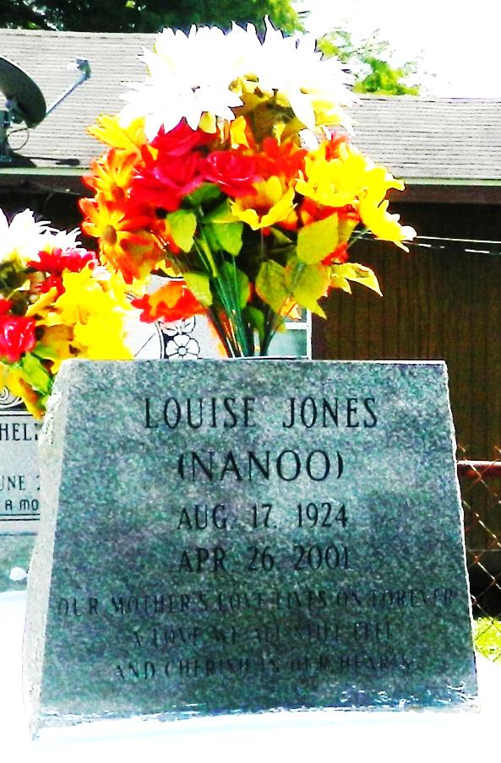

LAPLACE - Louise "Nanso" Jones, 76, a native of Lions and resident of Reserve, died April 26. She was the mother of Hilton and Donnie Johnson, Michael and Myron Creecy, Evelina Chamblee, Sheila Caeser and Carmen Holland and stepmother of Laural Alexander, Dottie Jackson, Barbara Johnson, Johnny Creecy, Leland Creecy and the late Eddie Creecy Jr. and Albertine Gray. She was also the sister of Eddie Jones and the late Felix Jones Jr. She is also survived by 50 grandchildren and 80 great-grandchildren. Services were May 4 at Providence Baptist Church, LaPlace, with interment at Rest Haven Cemetery, LaPlace.

L'Observateur, LaPlace, LA; May 05, 2001

Submitted for the LA GenWeb Archives by: Donald W. Johnson