Oneda (Gregoire) Joseph

Abt. 1931 – December 11, 2019

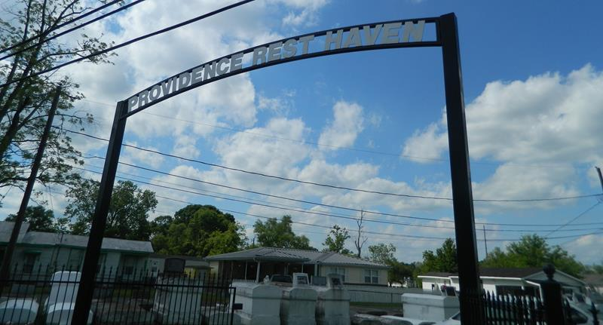

Oneda Gregoire Joseph "Peace y" on Wednesday, December 11, 2019 at her home in LaPlace, LA. Daughter of the late Kalsaw and Gertie Himes Gregoire. Wife of the late Clinton Joseph, Jr. Mother of Pamela Marie Joseph and Gary Wayne (Doretha) Joseph. Sister of Geneva Gregoire, the late Vera Anne Bell, Nelson, Charles and Joseph Gregoire. Also survived by 8 grandchildren, 21 great grandchildren and a host of nieces, nephews, cousins, other relatives and friends. Age 88 years. A native and a resident of LaPlace, LA. Relatives and friends of the family, also pastors, officers and members of Providence Baptist Church and all neighboring churches are invited to attend the Funeral Service at Providence Baptist Church, 240 Pine Street, LaPlace, LA on Saturday, December 14, 2019 at 11:00 AM. Rev. Willie Smith, Pastor, Officiating. Interment Providence Cemetery, LaPlace, LA. Visitation at the above named church from 9:00 AM until Service ONLY. SERVICED BY ROBOTTOM

Published in The Times-Picayune (New Orleans, LA) on Dec. 13, 2019