Evola (Warren) Keller

June 1, 1937 – September 8, 2010

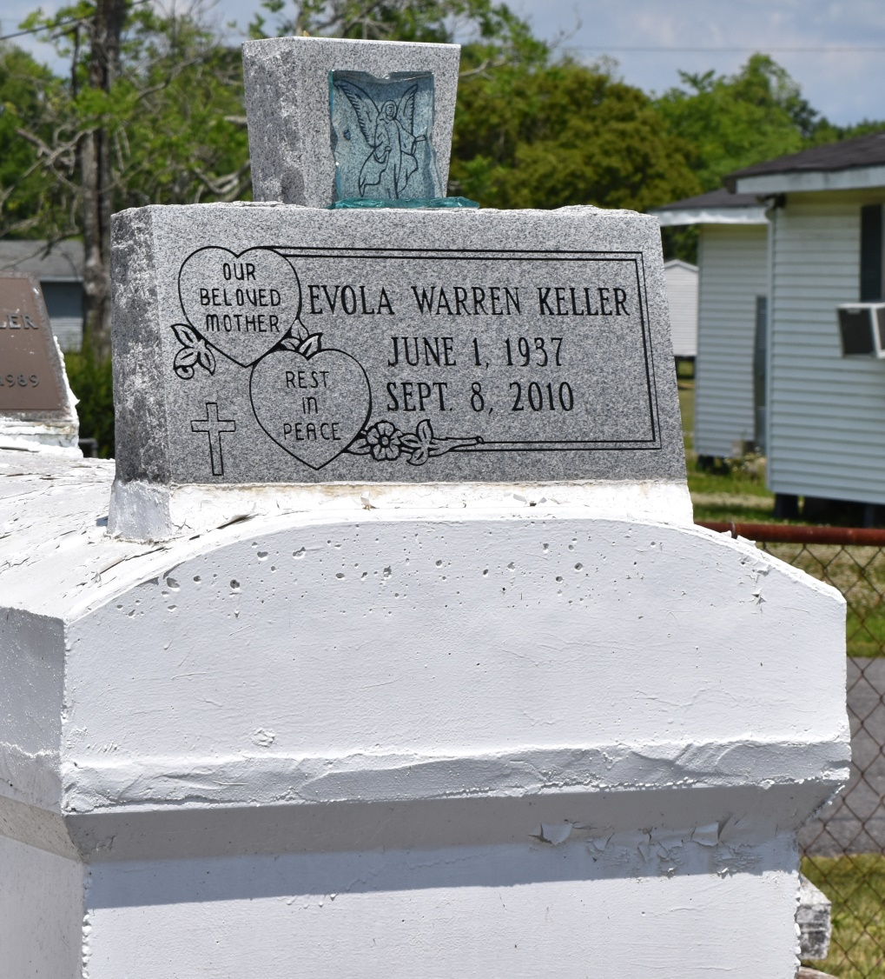

Evola Warren Keller entered into eternal rest on Wednesday, September 8, 2010 at her residence in Laplace, La. Daughter of the late Bishop Joseph Warren Sr. and Mary Louise Hoffman Warren. Wife of the late Raymond Anatole Keller. Loving mother of Jacqueline (Herman) Mitchell, Joycelyn (Perry) Joseph Sr., Patricia (Anderson) Harper, Christopher (Michelle) Keller, Delisa (Ray Allen) Jasper, Cornell (Gertie) Keller and Marsha (Terry) Walker. Sister of Cloria Clark, Selina (Robert) Paul, Mary Boatner and Benjamin (Verna) Warren. She is also survived by a host of nieces, nephews, brothers and sisters in law, cousins, 23 grandchildren, 17 great-grandchildren, and friends. Age 73.  
  
Relatives and friends of the family; Pastors Officers, and members of Greater Morning Star B.C. and all neighboring churches; employees of St. John School Board, Cargill Grain Elevator, CGB Marine, Nalco, Wal-Mart, ADM Grain and St. James Stevedoring Co. are invited to attend the funeral service on Wednesday, September 15, 2010 at 11:00 a.m. at the above named church, 1003 Balsam St., Laplace, La. Rev. Bryant K. Warren, Officiating. Visitation will begin at 9:00a.m. Interment in Providence Rest Haven Cemetery. Laplace, LA.  
  
Professional Service Entrusted to Hobson Brown Funeral Home, Garyville, LA 70051,   
985-535-2516

Times-Picayune, The (New Orleans, LA) - Tuesday, September 14, 2010

Contributed by Jane Edson