Rayquan M. Mason

Abt. 1995 – July 15, 2019

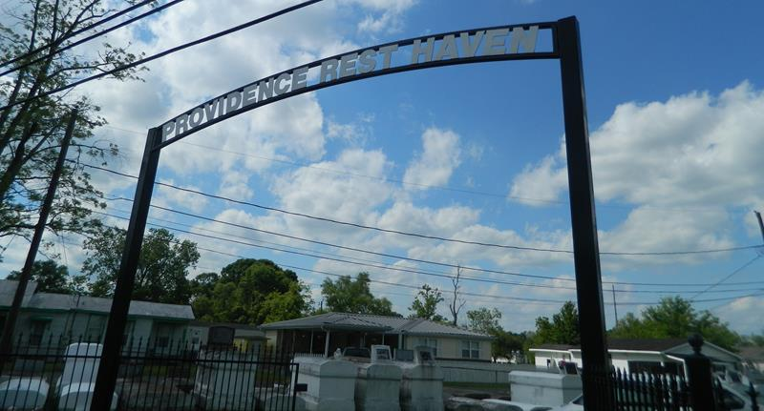

Rayquan M. Mason on Monday, July 15, 2019 at Ochsner River Parishes, LaPlace, LA. Son of Raydell Mason Sr. and Taquana Z. Mason. Brother of Raydell Mason Jr. and DeMario Perrilloux. Also survived by 1 nephew Dallas Perrilloux and a host of aunts, uncles, cousins, other relatives and friends. Age 24 years. A native and a resident of LaPlace, LA. Relatives and friends of the family, also pastors, officers and members of Rising Star and New Rescue Mission Baptist Churches and all neighboring churches and employees of Healing Hands are invited to attend the funeral service at Rising Star Baptist Church, 620 Cardinal Street, LaPlace, LA on Saturday, July 27, 2019 at 10:00 AM. Rev Donald August, Pastor, Rev. Devin Mason, Pastor of New Rescue Mission Baptist Church, Officiating. Interment Providence Cemetery. LaPlace, LA. Visitation at the above-named church from 8:00 AM until service time. SERVICED BY ROBOTTOM.

Published in The Times-Picayune on July 26, 2019