Dennis Mitchell

August 13, 1976 – January 14, 1999

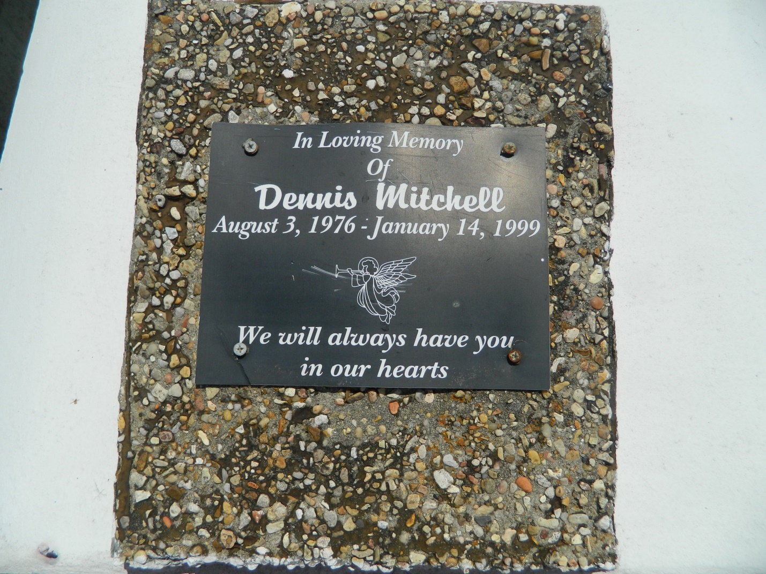

Dennis Mitchell, 22, a native of Reserve, died Jan. 14. He was the husband of Catrina Mitchell and father of two. He was also the son of Junius Sr. and Darlene M. Thomas and brother of Junius Jr., Quiana, Rochelle and the late Ricky Thomas. Services were held Jan. 19 at Mt. Calvary Baptist Church, Reserve, with interment at Providence Resthaven Cemetery.

L'Observateur, LaPlace, LA; January 20, 1999