Gladys (Hymes) Mitchell

April 21, 1913 – October 4, 2004

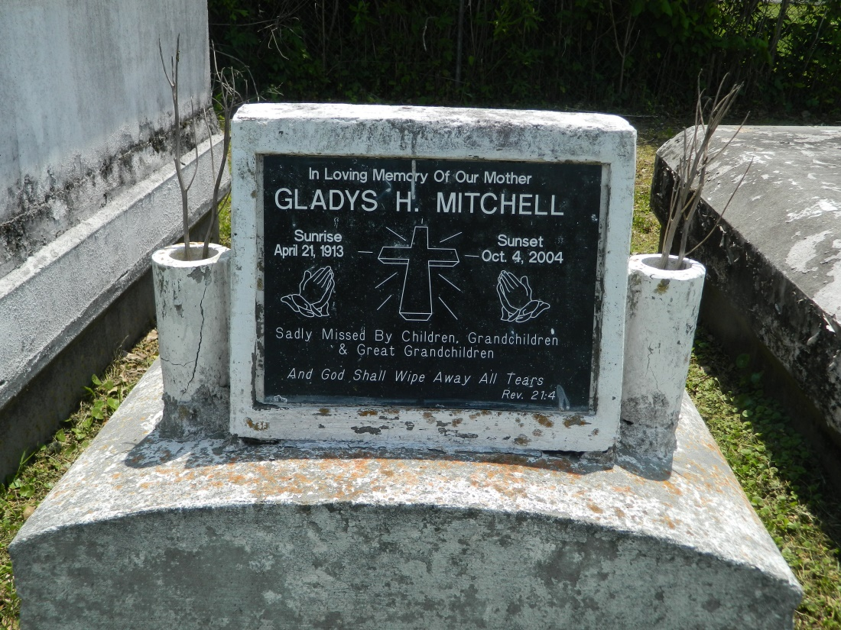

LAPLACE - Gladys Mitchell, 91, a native of Lucy and resident of Reserve, died Oct. 4. She was the wife of the late Rev. Hilton Mitchell Sr., and mother of Glythina Batiste, Hilton Jr., Donald, and the late John and Ronnie Mitchell.  
  
She was also the daughter of the late Martha Taylor and Curly Hymes, and half-sister of the late Nancy and Smitty Hymes.  
  
She is also survived by 15 grandchildren, 22 great-grandchildren and seven great-great-grandchildren.  
  
Services are today at 10 a.m., at Providence Baptist Church No. 1, Reserve, with interment at the church cemetery. Visitation starts at 9 a.m.

L'Observateur (La Place, LA) - Monday, October 11, 2004

Contributed by Jane Edson