Georgia Mae (Green) Moore

June 26, 1943 – June 26, 2006

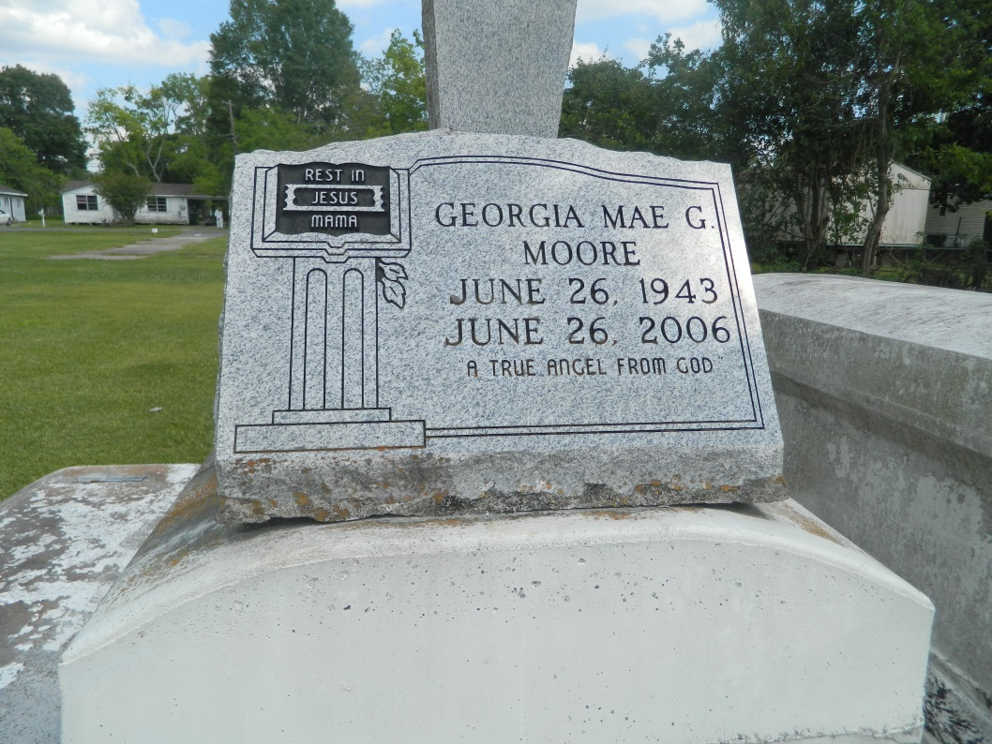

Georgia Mae Moore, a homemaker, passed away peacefully on Monday, June 26, 2006 in Thibodaux, La. Age 63. Daughter of the late Lloyd Green and Sophia Johnson. Wife of Charlie Moore. Mother of James Otis, Raynell, Sabrina and Sophia Moore and Angela Williams. Sister of Otis Green, Lois G. Hester and the late Cenovia Williams. Mother-in-law of Tedre Moore and Dewayne Anderson. Also survived by 8 grandchildren, a host of aunts, uncles, nieces, nephew, sisters- and brothers-in-laws, other relatives and friends. A native and resident of Reserve, La.  
  
Relatives and friends of the family, officers, and members of Greater New Plymouth Rock B.C. and all neighboring churches are invited to attend the Homegoing Service on Monday, July 3, 2006 at 12:00 noon from the above named church, 110 NW13th St. Reserve, La. Reverend David B. Carter, Pastor - Officiating. Interment in Providence Rest Haven Cemetery, LaPlace, La. Visitation from 10:00a.m. until service time.  
  
Service entrusted to HOBSON BROWN FUNERAL HOME, Garyville, LA

Times-Picayune, The (New Orleans, LA) - Sunday, July 2, 2006

Contributed by Jane Edson