Jerome A. Powers

1966 – June 13, 2013

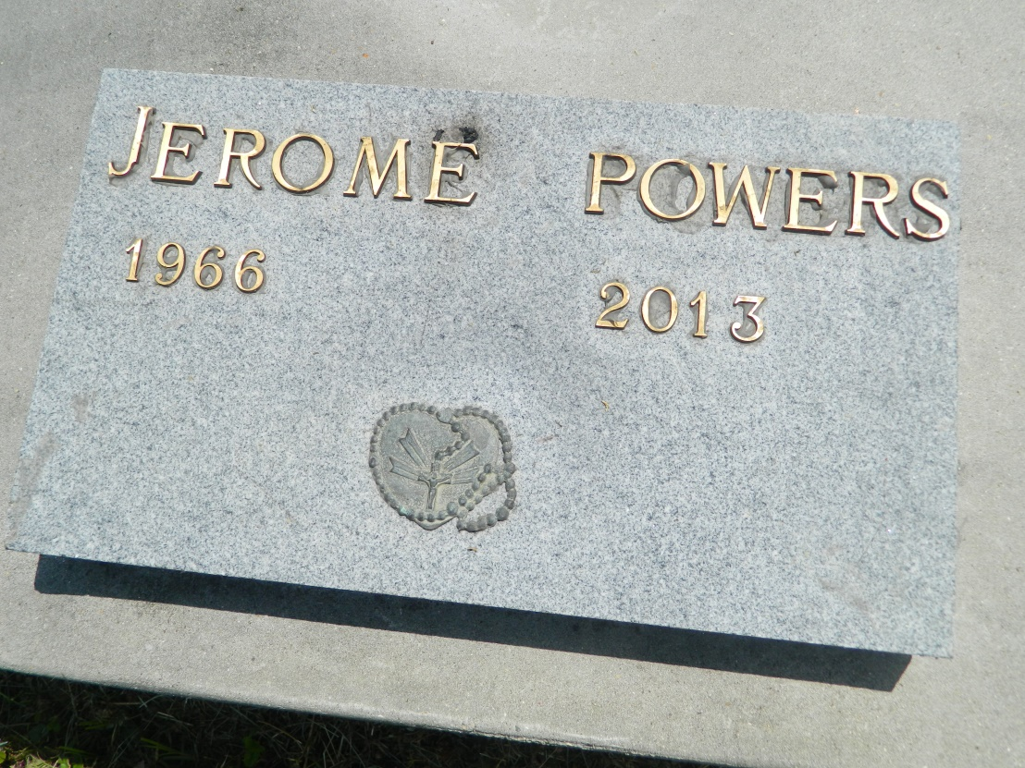

Jerome A. Powers passed away peacefully on Thursday, June 13, 2013, at the age of 46 years old. Beloved son of Leroy and the late Georgia Mae Powers. Stepson of Harriet L. Powers. Grandson of the late Corrith Powers. Brother of Darrell, Michael (Shantell), Patrice (Philman), Rosda, Ciara, Le'Jonie Powers, Catina (Emmanuel) Lang, Curtis Randall, and the late Leroy Lang. Also survived by host of nieces, nephews, cousins, other relatives and friends.  
  
Funeral services will be held on Saturday, June 22, 2013, for 11:00 a.m. at Providence Baptist Church #1, 228 Pine Street, Laplace, La. Pastor Willie Smith will be officiating. Interment will be at Providence Cemetery, Laplace, La. Funeral entrusted to The Baloney Funeral Home, LLC, 1905 W. Airline Highway, Laplace, La., 985-224-8460. Condolences can be expressed at [www.baloneyfuneralhome.com](http://www.baloneyfuneralhome.com/).

Times-Picayune, The (New Orleans, LA) - Friday, June 21, 2013

Contributed by Jane Edson