Ida (Watkins) Roberts

May 23, 1941 – January 24, 2009

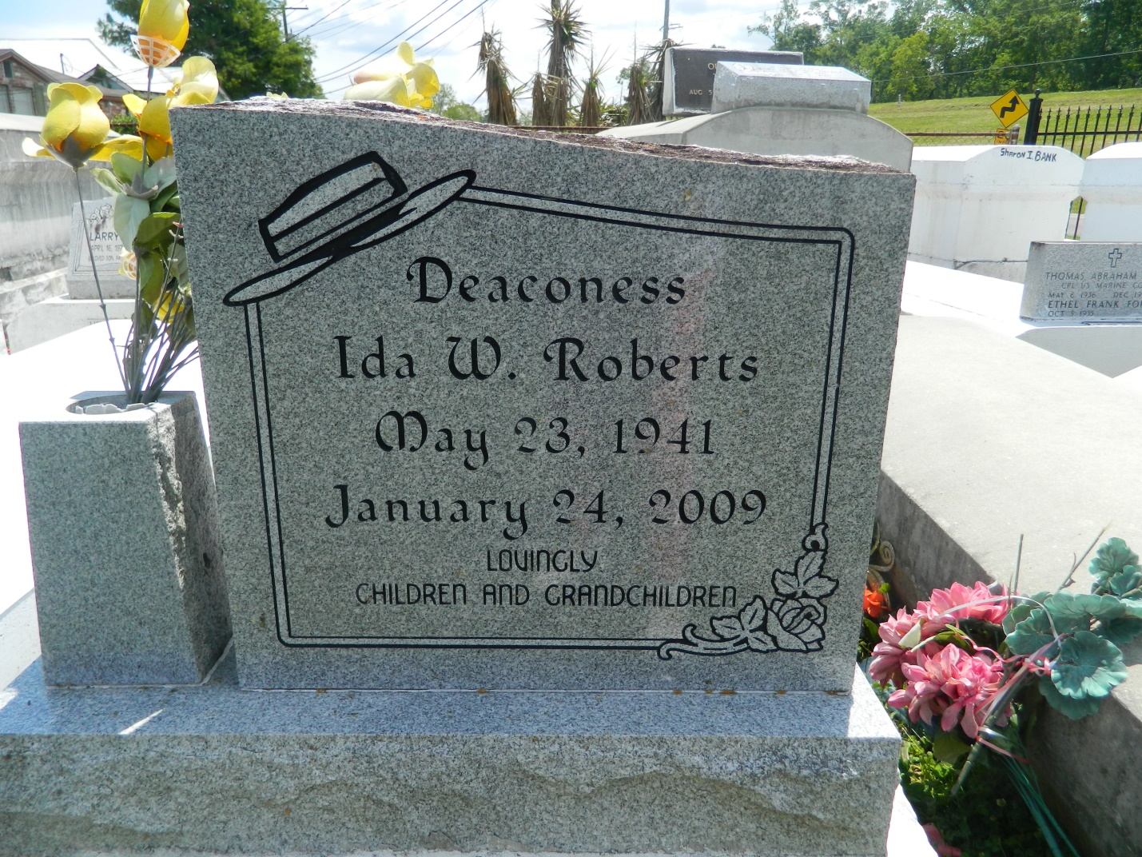

Deaconess Ida W. Roberts entered into the pearly gates on Saturday, January 24, 2009. Daughter of the late Thomas Watkins and Sarah W. Keller. Wife of the late Earl Roberts, Sr. Mother of Elder Montrell S. Roberts, New Orleans, La, Evangelist Earl B. Roberts, Mandeville, LA, Myron J. Roberts, Laplace, LA and LaToya K. Roberts, Gretna, LA. Grandmother of Elizabeth A. Roberts, Chicago, IL, Elijah J. Roberts, Mandeville, LA, Chancellor T. Ellis, Gretna, LA, Maya A. and Amaru T. Roberts, LaPlace, LA. Mother-in-law of Marilyn Roberts, Mandeville, LA and Ann M. Roberts, LaPlace, LA, Former son-in-law Chad T. Ellis, Slidell, LA. Godmother of Harold Brown, Jr., Paris, France and Vada Lennix, LaPlace, LA. Also survived by a host of other relatives and friends.  
  
Relatives and friends of the family, also Pastors, officers, members of and employees of Providence Baptist Church #1, Legos Christian Fellowship, Progressive Word Fellowship, Christian Love Baptist Church, His Sanctuary of Ministries, Franklin Ave Baptist Church, and neighboring churches, Good Samaritan Nursing Home and Rehabilitation Center, Office of Family Support, Sheraton New Orleans Hotel and Galland Roofing Company are invited to attend funeral services from Providence Baptist Church #1, 240 Pine St, LaPlace, LA. On Saturday, January 31, 2009 at 10am. Reverend Willie Smith Officiating. Visitation at 8am. Interment Providence Resthaven Cemetery, LaPlace, LA.  
  
Services entrusted to Louisiana Undertaking Co., 1449 N. Claiborne Ave., New Orleans, La 70116, 504-945-2145. Jeffery K. Jenkins/ Renard Boissiere-Directors

Times-Picayune, The (New Orleans, LA) - Friday, January 30, 2009

Contributed by Jane Edson