Shirley (James) Schnyder

November 22, 1934 – May 12, 2011

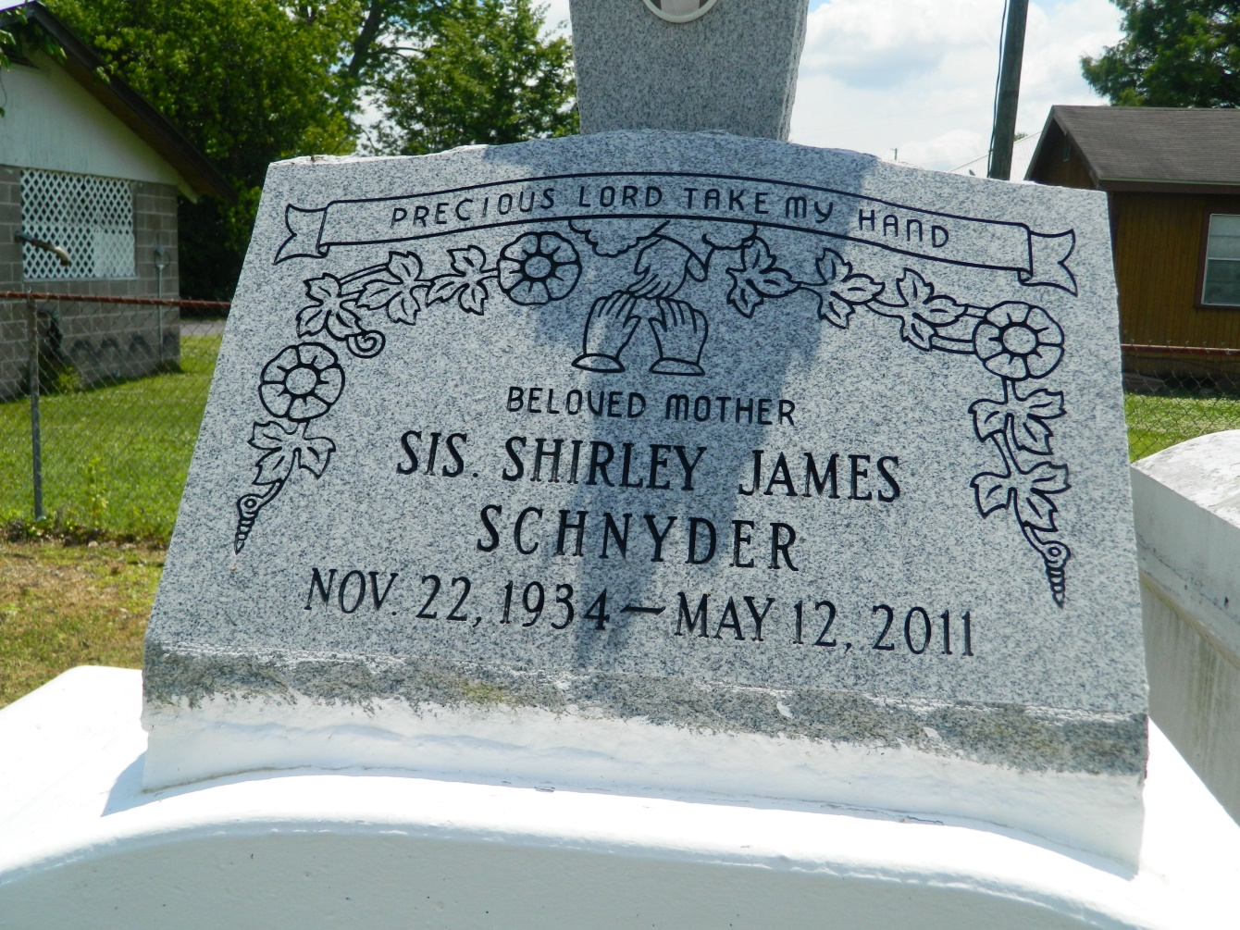

Shirley James Schnyder, age 76, a lifelong resident of Reserve, LA, passed away on Thursday, May 12, 2011 in Kenner, LA. She was the beloved wife of the late Allen Schndyer, Sr. Devoted mother of Aubrey Sr. and Ky Wilson; and five stepchildren: Allen, Damian, Tonia and Darren Schnyder and Andreana Conner; and fifteen grandchildren. She was the daughter of the late Peter Sr. and Beulah James. She was the sister of the late Ethel Johnson, Alma Sentimore, Viola Staggers, Gussie Bell Joseph, Thelma Lee Wilson, Ceola Nabors, Ulysses, Leonard, Melvin, Nolan and Peter James, Sr. Relatives, friends, and members of Providence Baptist Church, visiting churches and Dobb House are invited to attend a visitation at Providence Baptist Church, 286 Pine Street, LaPlace, LA on Thursday, May 19, 2011 from 9:00 a.m. until service starts at 11:00 a.m. Interment will be at Providence Rest Heaven Cemetery.

Times-Picayune, The (New Orleans, LA) - Thursday, May 19, 2011

Contributed by Jane Edson