Robin Ann (Gerard) Smith

August 8, 1960 – August 7, 2004

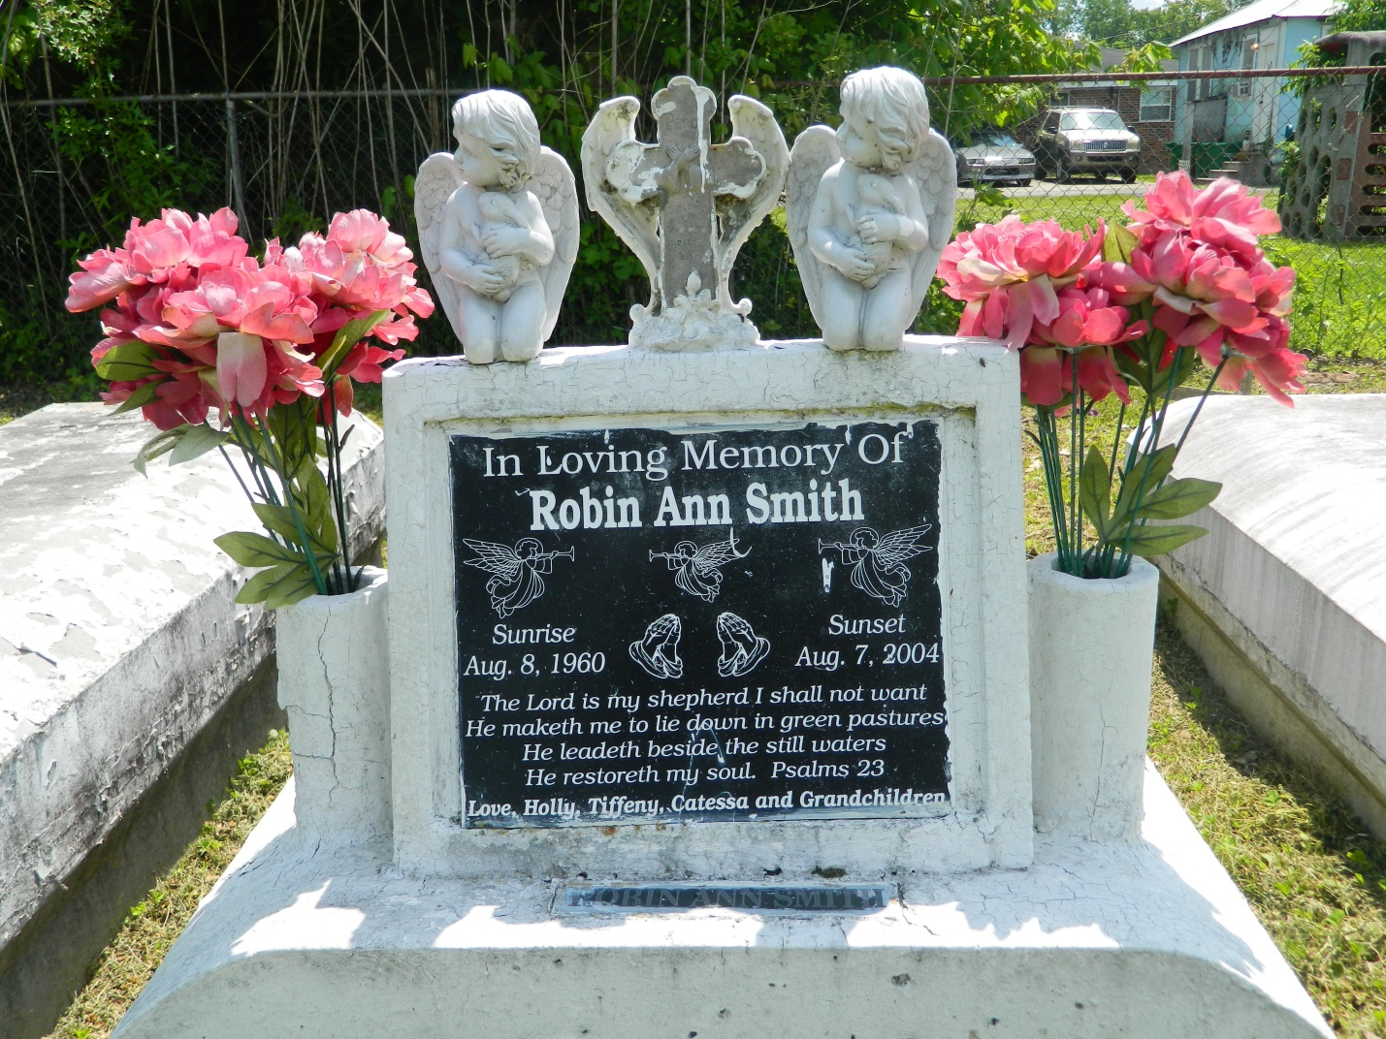

Robin Ann (Peazy) Smith departed this life on Saturday, August 7, 2004 at Tulane Hospital, New Orleans, LA. Daughter of Isabelle Howard Gerard and the late Earl Gerard, Sr. Mother of Holly Ann Green, Tiffeny Smith and Catessa Warren. Sister of Apostle Earl Gerard III, Geraldine, Micheal, John, Gary, Rachel and Troy Gerard, Lurline Warren, Joleane Patterson, Rose Bolden, Andrea Boudreaux, Audrey Head and Sadie Taylor. Granddaughter of the late Gustave and Laura Howard, 5 grandchildren and1 son-in-law, Reginald Green. Also survived by a host of aunts, uncles, nieces, nephews, cousins and friends. A native and resident of LaPlace, LA. Age 43 years.  
  
Relatives and friends of the family; pastors, officers and members of Spirit of Liberty Full Gospel Church and all neighboring churches are invited to attend Funeral Services on Saturday, August 14, 2004 at 11:00 a.m. at the above named church, 603 Main St., LaPlace, LA. Visitation will begin at 9:00 a.m. until funeral time. Apostle Earl Gerard III, Pastor - officiating. Interment in Providence Cemetery, LaPlace, LA.  
  
FAMILY WISHES YOU A HAPPY BIRTHDAY  
  
Services entrusted to HOBSON BROWN FUNERAL HOME, Garyville, LA

Times-Picayune, The (New Orleans, LA) - Friday, August 13, 2004

Contributed by Jane Edson