Thelma Mae (Graham) Smith

May 8, 1936 – May 26, 2012

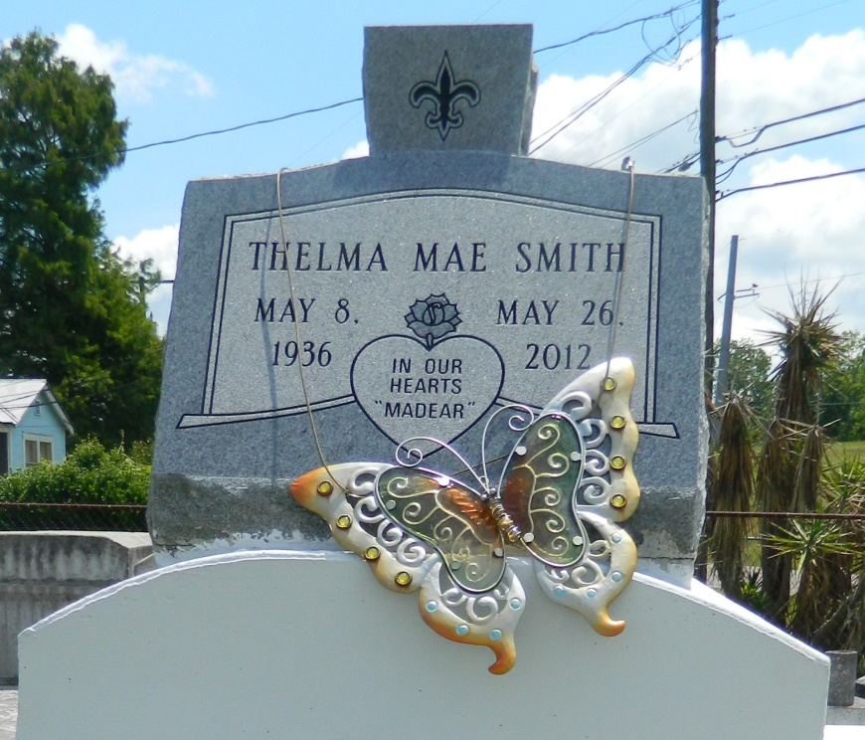

Thelma Mae Smith (a.k.a. MaDear or Dear) departed her earthly life on Saturday May 26, 2012. She was the daughter of the late Nathan Graham Sr. and Maggie Bell Neal. She was raised and loved by the late Big Thelma Moten and Papa John Tillman who were the apples of her eye. She devoted her life, friendship, and love for 57 years to the late Edward Smith Sr. She left behind seven children Edward (Darlene) Smith Jr., Llewellyn (Sonya) Smith, Gwendolyn (Ricky) Morgan, Renita (Kevin) Branch Sr., (Late Avery Smith), Christy (Dwayne) Myers, Shandelyn (Ralph) Vampran, and Chalander Smith. Sister of Wanda (Wallace) Diaz, Joseph (Diana) Graham, Enola Brown, Dennis Brown, and the late Nathan Graham Jr. She is also survived by 23 grandchildren, 30 great-grandchildren, an abundance of sisters-in-law, brothers-in-law and nieces and nephews.  
  
Pastor, Officers, and members of Providence Baptist Church #1, all neighboring churches, relatives and friends, are invited to attend the home going celebration on Saturday, June 02, 2012 at 11:00 a.m. Services will be held at Providence Baptist Church #1 (Rev. Willie Smith Officiating Pastor) 240 Pine Street, La Place, LA 70068. Visitation will begin at 9:00 a.m. Interment follows at Providence Rest Haven.  
  
Professional Service Entrusted to Hobson Brown Funeral Home, 134 Daisy St., Garyville, LA 70051, (985) 535-2516.

Times-Picayune, The (New Orleans, LA) - Friday, June 1, 2012

Contributed by Jane Edson