Melvin Sylvan
December 27, 1930 – August 24, 2004

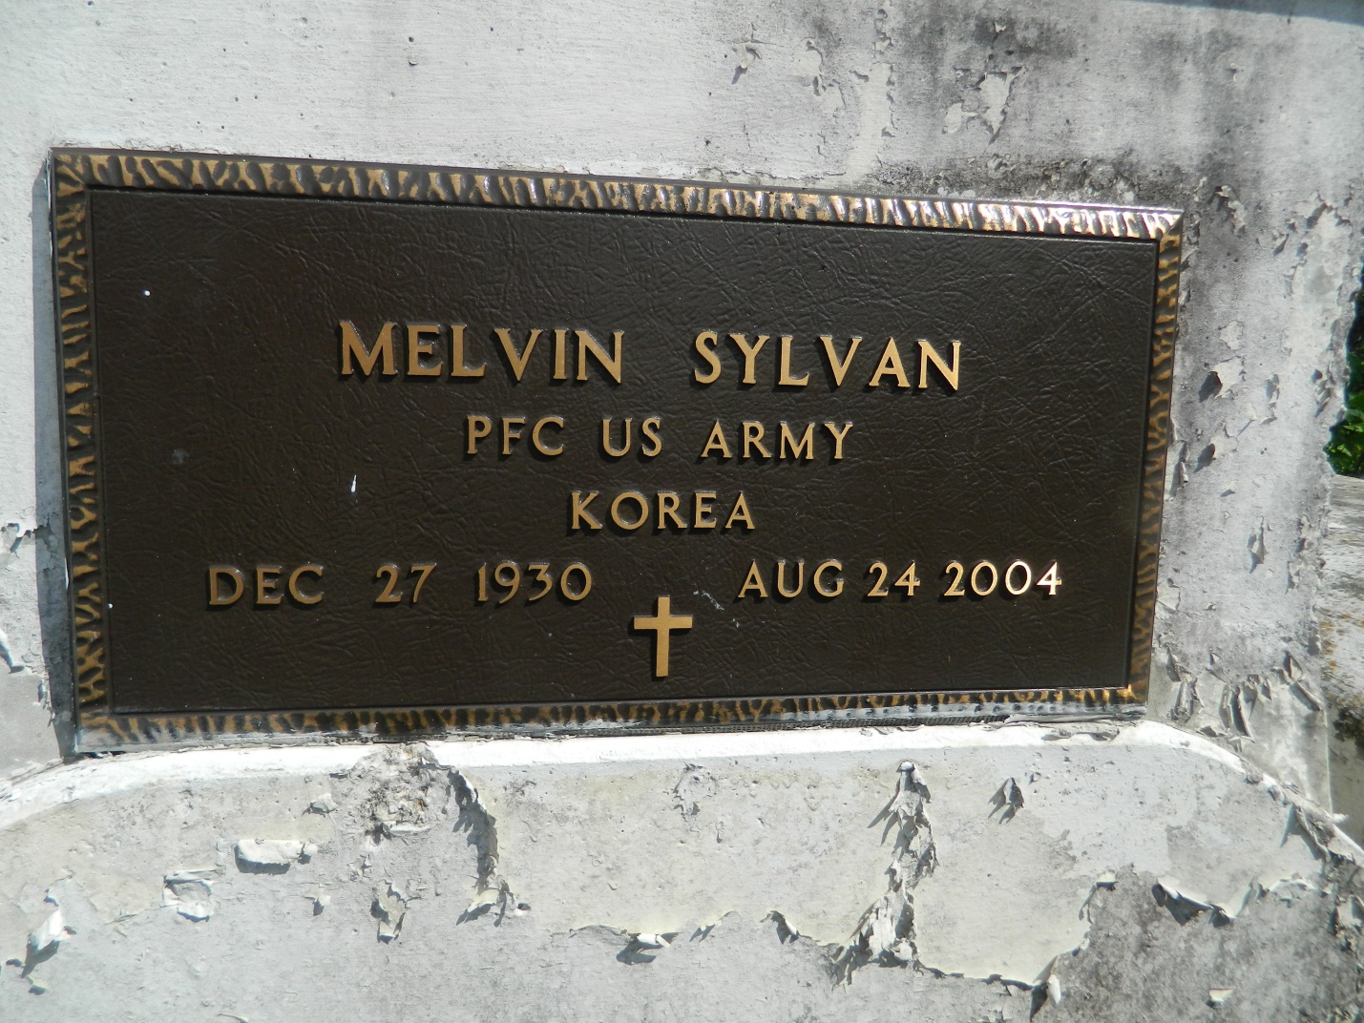

Melvin Sylvan, a laborer at Domino Sugar, died Aug. 26 of pulmonary embolism at his home. He was 73. Mr. Sylvan was a lifelong resident of LaPlace. Survivors include a son, Hank Sylvan of Kent, Wash.; two daughters, Sylvia Washington of Reno, Nev., and Betty Joseph; two stepdaughters, Leah Davis and Jaszmin Jasper; three brothers, Clarence, Lawrence and Joshua Sylvan; a sister, Helen Morgan; 12 grandchildren; and 12 great-grandchildren. A funeral will be held today at 11 a.m. at Mount Calvary Baptist Church, 127 W. Third St., LaPlace. Burial will be in Providence Rest Haven Cemetery. Hobson Brown Funeral Home is in charge of arrangements.

Times-Picayune, The (New Orleans, LA) - Saturday, September 4, 2004
Contributed by Jane Edson

