Glenda (Davis) Williams

July 1, 1957 – November 21, 2013

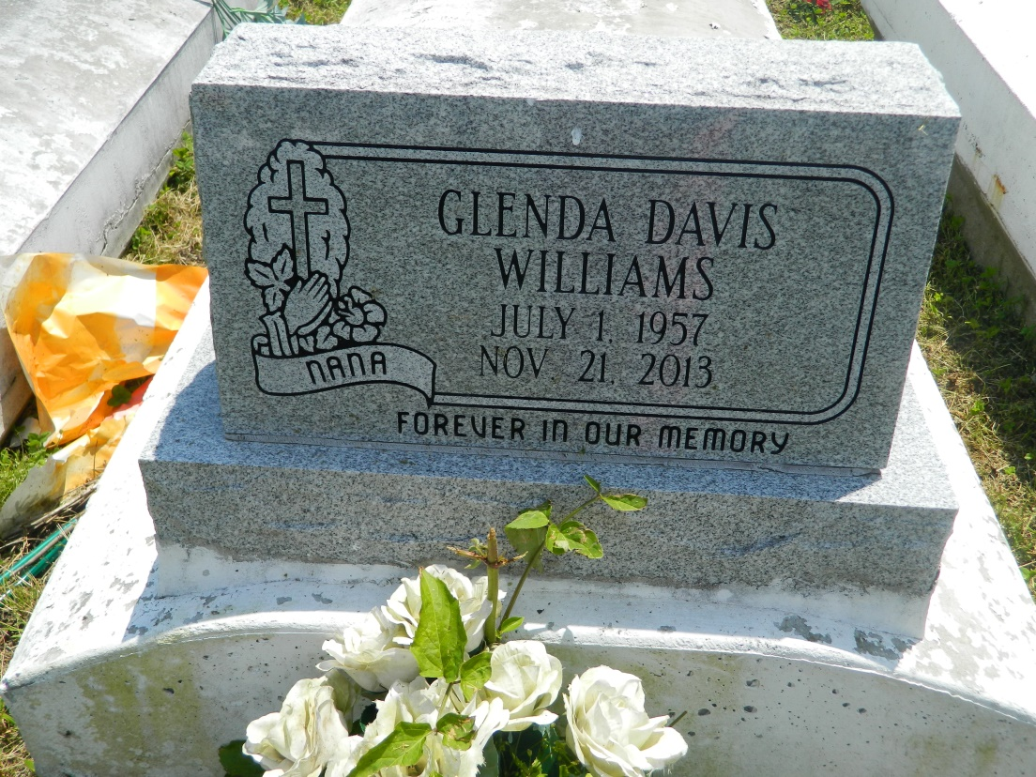

Glenda Davis Williams ascended to heaven to receive her wings on Thursday, November 21, 2013 at Ochsner Hospital, Jefferson, LA. Loving daughter of Rosa Mae Davis and the late Harrison Davis. Mother of Ephraim, III, Eddrin, Roydell and Roderick Williams. Sister of Harrison Davis, III, Betty Davis, Cheri Davis Anderson, Regina Davis Dupard, Gary and Donald Ray Davis, Deidra Davis Alexis and the late Ronnie Davis. Grandmother of Aaliyah, Braylon and Alexis. Also survived by a host of nieces, nephews, cousins, other relatives and friends. Age 56 years. A native and resident of LaPlace, LA  
  
Relatives and friends of the family, also pastors, officers and members of Providence Baptist Church #1 and all neighboring churches, Graduates of Leon Godchaux Class of 1975 and employees of Brand Services, Motiva Enterprises, Emily C. Watkins Elementary, Cohen High School and Turner Industries are invited to attend the Funeral Service at Providence Baptist Church #1, 240 Pine Street, LaPlace, LA on Saturday, November 30, 2013 at 11:00 AM. Rev Willie Smith, Pastor, Officiating. Interment Providence Resthaven Cemetery, LaPlace, LA. Visitation at the above named church from 9:00 AM until service time.  
  
SERVICED BY ROBOTTOM

Times-Picayune, The (New Orleans, LA) - Friday, November 29, 2013

Contributed by Jane Edson