Brad Anthony Alexander

Abt. 1952 – April 12, 2017

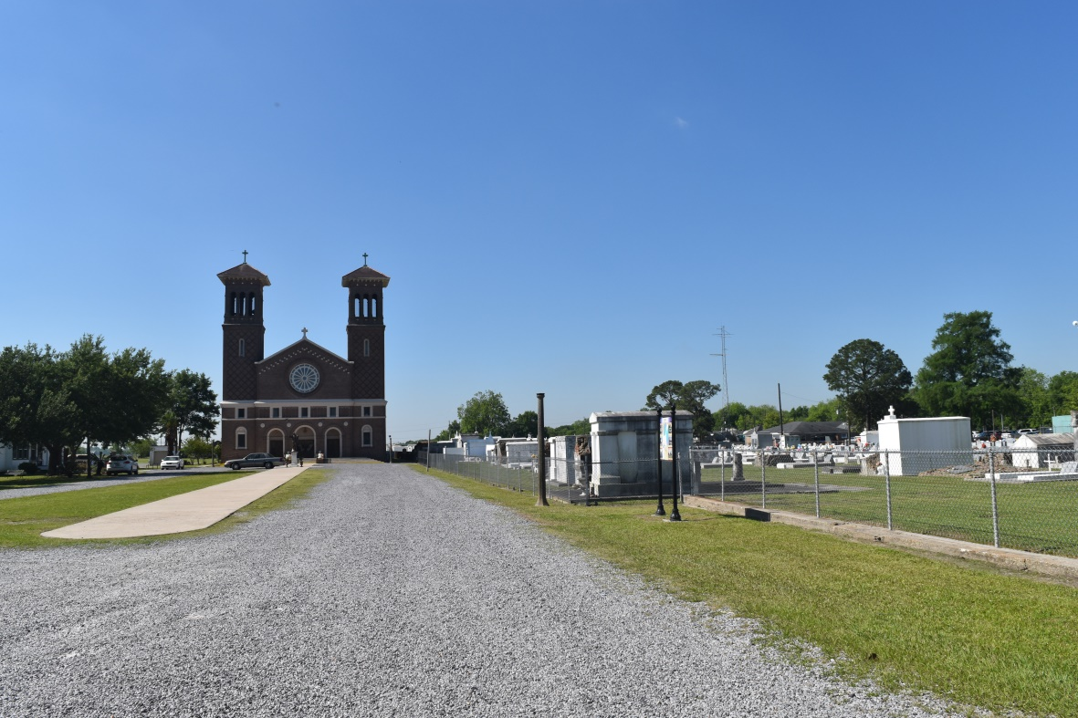

Brad Anthony Alexander received his angel wings and went home to glory on Wednesday, April 12, 2017 at 3:15 pm at the age of 65. Beloved son of the late Lawrence “Pop” Alexander. He is preceded in death by his sisters; Jane Doris Alexander, Evette Marie Alexander, Emma Lou Alexander Watson and his brother, Ronald “Zonk” Alexander. He leaves behind to mourn his death, his mother Rose “Mum” Borne Alexander, brothers and sisters’ Betsy Jackson, Lawrence Alexander Jr., Nashid Salauddin (Irene), Yvonne Minor Weber (Oscar), Paulette Cobb, Carter Alexander (Nellie), Stacey Harris, Diana Alexander Keller (David), Monica Alexander LaSalle (Hilton), Tyrone Alexander (Lou Anna) and Ray Alexander. His aunt Eloise Fiffie and a large host of nieces, nephews, cousins, other relatives and many friends. Pastors, officers and members of St. Joseph the Worker Roman Catholic Church, Morning Star Missionary Baptist Church, Dominion and Power Ministries, Second Zion Baptist Church and all other neighboring churches are invited to attend the funeral services held at St. Joseph the Worker Roman Catholic Church, 455 Ames Boulevard Marrero, Louisiana 70072 on April 22, 2017.Complimentary Viewing will take place from 2-4pm at the Baloney Funeral Home, LLC 1905 W. Airline Hwy Laplace, Louisiana 70068. Visitation will begin at 8:00am followed by Recitation of the Rosary at 8:30am and the Celebration of Life at 9:15am. Immediately following will be a 10:00am Mass of Christian Burial. Rev. Eugene F. Jacques officiating. He will be laid to rest upon completion of Mass Celebration at St. John the Baptist Catholic Church Cemetery located at 2349 LA-18 Edgard, Louisiana 70049. The Alexander Family would like to extend a special thanks to the following; West Jefferson Medical Center, Amedisys and Eagan Home Health Services, Inspiration House, West Care Medical Center, Canon Hospice Care, West Bank ARC, Hammond State School, Home Health Care, Quality Independent Service Coordinators and all others with whom lended their helping hands with dedication and love. We truly appreciate your wonderful support. Arrangements Entrusted to The Baloney Funeral Home, LLC 1905 W. Airline Hwy Laplace, Louisiana 70068 (985)224-8460. Condolences can be expressed at [www.baloneyfuneralhome.com](http://www.baloneyfuneralhome.com)

Baloney Funeral Home online obit (accessed 6/19/2018)