Ferdinand Alexander

April 14, 1927 – September 21, 2004

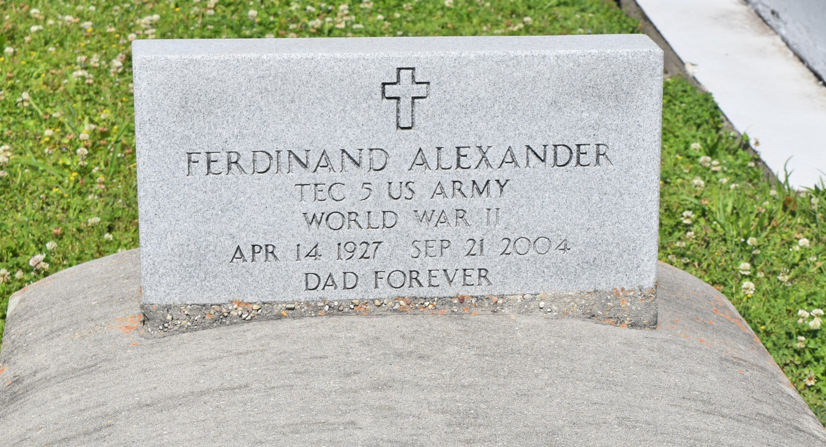

Ferdinand "Connie" Alexander, a retired employee of the St. John the Baptist Parish school system, died Sept. 21 of a heart attack at St. Charles Parish Hospital. He was 77. Mr. Alexander was born in Lucy and lived in Edgard. He also worked as a truck driver for Dinvaut's Trucking Co.

Survivors include eight sons, Ferdinand, Terry, Gerald, Chris, Tracy, Brian, Dwight and Michael Alexander; five daughters, Diane Boudoin, Patsy Andrews, Vanessa Johnson, Debra Brown and Melissa Alexander; 42 grandchildren; and 10 great-grandchildren. A Mass will be said today at 11 a.m. at St. John the Baptist Catholic Church, 2361 River Road in Edgard. Visitation will begin at 9 a.m. Burial will be in the church cemetery. The Baloney Funeral Home is in charge of arrangements.

Times-Picayune, The (New Orleans, LA) - Tuesday, September 28, 2004

Contributed by Jane Edson