Nolia Alexander

February 5, 1956 – May 9, 2013

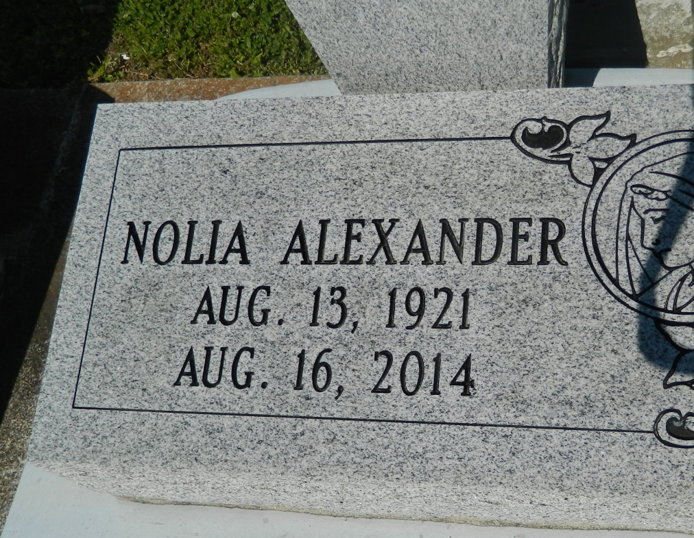

NOLIA ALEXANDER on Saturday, August 16, 2014 at St. James Parish Hospital, Lutcher, LA was called by God to join him in eternity.  
  
Daughter of the late Lucille Samuel and Willie Alexander. Sister of the late Sidney Alexander, Sr., Fredrick Louper, and Elvinar "Mary" Alexander. Aunt of Mazie Bastian, Barbara Rainey and Donna Alexander all of Edgard, LA, Earline Johnson of Hahnville, LA and Jean Dillon of Philadelphia, PA. Also survived by a host of great and great great nieces and nephews, Godchildren, other relatives and friends. Age 93 years. A native of Edgard, LA and a resident of Paulina, LA.  
  
Relative and friends of the family, also priests and parishioners of St. John the Baptist Catholic Church and all neighboring churches are invited to attend the Funeral Mass at St. John the Baptist Catholic Church, 2361 Highway18 (River Road), Edgard, LA on Saturday, August 23, 2014 at 11:00 AM. Father Robustiano Morgia, Celebrant. Interment St. John the Baptist Cemetery, Edgard, LA. Visitation at the above named church from 9:00 AM until Mass time.  
  
SERVICED BY ROBOTTOM

Times-Picayune, The (New Orleans, LA) - Friday, August 22, 2014

Contributed by Jane Edson