Terry Joseph Alexander

February 5, 1956 – May 9, 2013

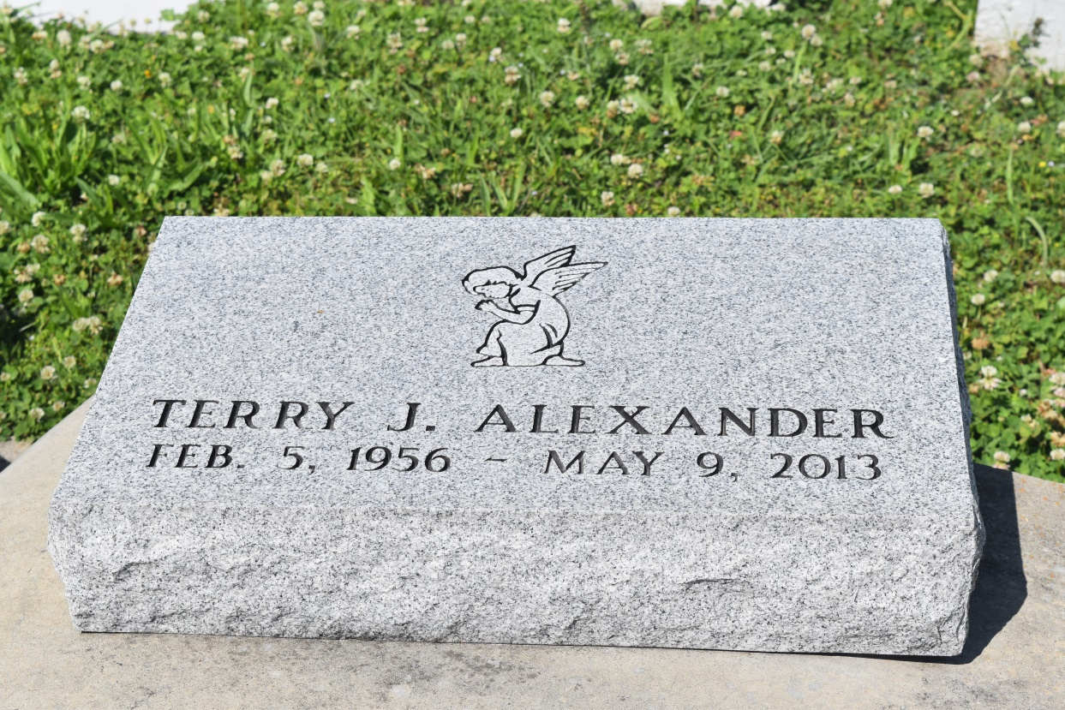

Terry Joseph Alexander, entered into eternal rest on Thursday, May 9, 2013, at the age of 57 years old. Son of the late Arcadia and Ferdinand Alexander. Husband of Rosalie Alexander. Father of Theresa (Henry) Thomas and Steven (Andrea) McCoy. Grandfather of Amiyah and Ja'shaun Thomas. Brother of Gerald (Donna), Chris (Allison), Tracy (Jawanda), Brian (Ninette), Dwight (Trina), and Micheal (Catina) Alexander, Dianne (Daniel) Boudoin, Vanessa (Welton) Johnson, Debra (Calvin) Preston, Patsy Andrews, and Melissa Alexander. Also survived by a host of nieces, nephews, cousins, aunts, uncles, and other relatives and friends.  
  
Funeral services will be held on Tuesday, May 14, 2013 for 11:00 a.m. at Mt. Zion Baptist Church, 107 Magnolia Ridge Road, Boutte, La. Rev. Charles Johnson will be officiating. Visitation will be from 10:00 a.m. until time of service. Interment will be at St. John The Baptist Catholic Church Cemetery, Edgard, La. Funeral entrusted to The Baloney Funeral Home, LLC., 1905 W. Airline Highway, Laplace, La., 985-224-8460.  
  
Condolences can be expressed at [www.baloneyfuneralhome.com](http://www.baloneyfuneralhome.com/).

Times-Picayune, The (New Orleans, LA) - Sunday, May 12, 2013

Contributed by Jane Edson