Elmo Joseph Alexis
April 20, 1934 – May 10, 2024

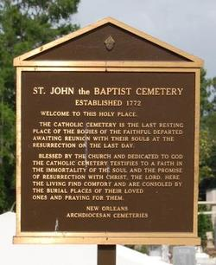

Elmo Joseph "Ploom", "Teama" Alexis was born on April 20, 1934, to Laurent and Nobia Schexnayder Alexis in Wallace, LA. He peacefully departed this life on May 10, 2024, at 2:10PM. Elmo was 90 years old and a resident of Edgard, LA.
He was employed by Avondale Shipyard for over 40 years. Elmo was a parishioner of St. John the Baptist Catholic Church in Edgard, LA. He was inducted into the United States Army and served during the Korean War. Elmo expressed his love for the great outdoors while spending much of his time fishing and hunting. He was also an avid gardener sharing the fruit of his work with family and friends.
Elmo leaves behind his legacy and memory to his loving wife of 63 years, Lorraine Mathieu Alexis; grandson, Kristopher Turner; 4 great-grandchildren; brothers, Lawrence Alexis (Marie) and Merlin Alexis; sisters, Delores Brown and Zenobia Bachemin; and a host of nieces, nephews, other relatives and friends. He was preceded in death by his parents, Laurent and Nobia Schexnayder Alexis; beloved daughter, Lennaire Carmel Alexis; brother, Harold Alexis; and sisters, Blanche Moll, Grace Populus, Olga Barnes and Gloria Crayton.
Relatives, friends of the family, and parishioners are invited to attend a Mass of Christian Burial on Saturday, May 18, 2024, at St. John the Baptist Catholic Church, 2349 LA-18, Edgard, LA 70049. Visitation will begin at 8AM with Mass to follow at 10AM. Recitation of the Holy Rosary at 9AM. Father Robustiano Morgia, celebrant. Entombment at St. John the Baptist Catholic Church Cemetery.

Treasures of Life Funeral Services, Gramercy, Louisiana
May 18, 2024

