Earline Marie (Edwards) Allen

June 7, 1937 – May 8, 2004

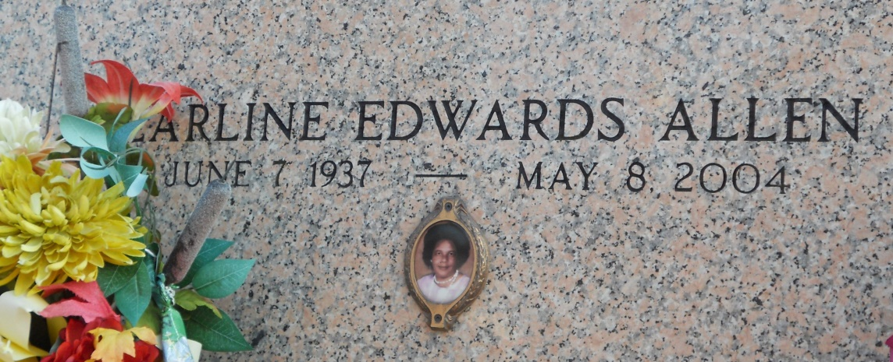

Photo by Team TLo

Earline (Neen) Marie Edwards Allen of Edgard, LA on Saturday, May 8, 2004 at 8:25 a.m. at Canon Hospice, Jefferson, LA.  
 Wife of the late Welmond Allen, Sr. Daughter of the late Ferdinand and Elsie Roussell Edwards. Mother of Glenn Edwards, Gerold Jolly, Rhondalyn Edwards, Nicole Allen of Edgard, La, Lynette James Of Vacherie, Randall Allen Of Stuttgart, Germany, Terrell Allen Of Killeen, Tx, Renee Roussell Of Mt. Airy, La And Welmond Allen, Jr. Of Ruston, La. Stepmother Of Nedra Allen Of Harvey, La. Sister Of Margaret Morris, Gustavia Bailey, Florence Brimmer, Ernestine Tuckerson, Tyronne, Allen, Clarence And Murray Edwards, Cheryl Louper, Elsie Jones, Constance Grows And The Late Ferdinand Edwards Jr. Also Survived By 21 Grandchildren, 4 Great Grandchildren, A Host Of Nieces, Nephews, Sisters And Brothers-In-Law, One Aunt, Cousins And Friends. A Native And Resident Of Edgard, La. Age 66 Years.  
 Relatives And Friends Of The Family, Also Priest And Parishioners Of St. John The Baptist Catholic Church, New Jerusalem B.C.-Edgard, Bethlehem B.C.-Hahnville, Our Lady Of Grace Catholic Church-Reserve, La And Neighboring Churches, Employees Of U.S.D.A./F.G.I.S., Bunge North America, Adm-Growmark, Cargill, Zennoh And Peavy Grain Elev., G.E. Capital-Laplace, La, Our Lady Of Grace School, Reserve, La, St. John Sheriff's Office, Gramercy Elem. School And U.S. Army Are Invited To Attend A Mass Of Christian Burial On Saturday, May 15, 2004 At 11:00 Am From The St. John The Bapt. Catholic Church, Edgard, La. Entombment Church Mausoleum. Visitation At The Church After 9:00 Am Saturday. Recitation Of The Rosary 10:00 Am The Baloney Funeral Home In Charge Of Arrangements  
  
Times Picayune, New Orleans, Louisiana

May 14, 2004