Augustine Hattie August
August 28, 1926 – November 20, 2011

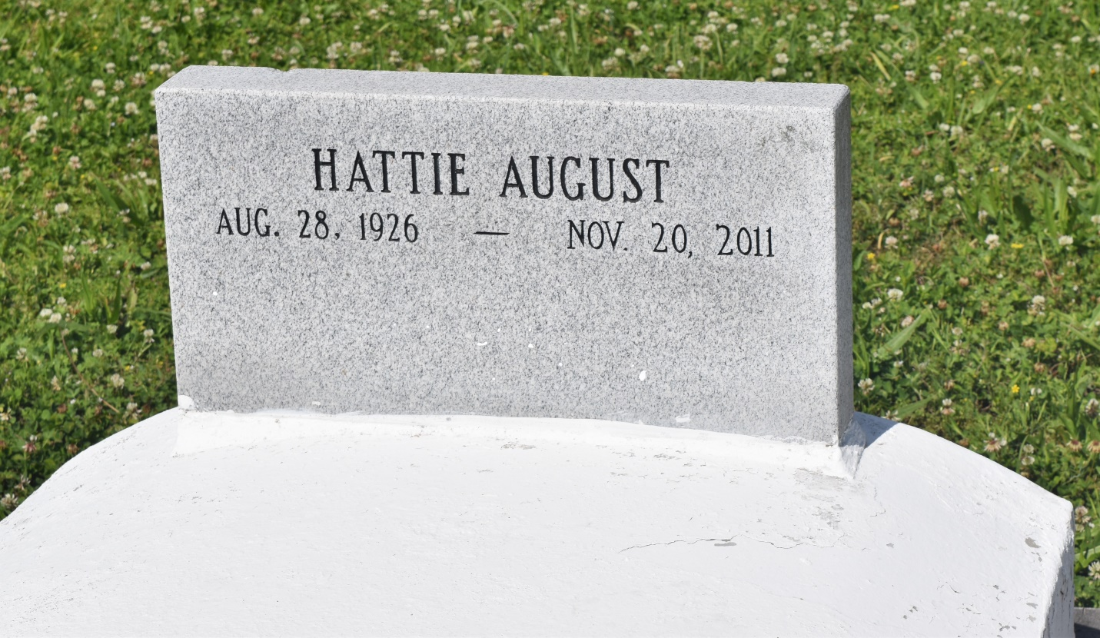

Augustine Hattie August on Sunday, November 20, 2011 at Luling Living Center, Luling, LA. Daughter of the late August and Anna Biarre August. She is survived by her companion, Mr. Welman Oubre, four godchildren: Stephen LaGrange, Jr., Olivia Fiffie, Brenda August and Lynell William, and a host of nieces, nephews, cousins, other relatives and friends. Preceded in death by one daughter Anna, and her siblings: Clifford August, Sr., Melonia and Lucielle LaGrange. Age 85 years. A native of Lucy, LA and a resident of Westwego, LA.
Relatives and friends of the family, also priest and parishioners of St. John the Baptist Catholic Church, St. Joseph the Worker Catholic Church of Marrero, LA and all neighboring churches are invited to attend the Mass of Christian Burial at St. John the Baptist Catholic Church, 2361 Highway 18, Edgard, LA on Tuesday, November 29, 2011 at 11:00 AM. Father Joel Cantone, Celebrant. Interment St. John the Baptist Cemetery, Edgard, LA. Visitation at the above named church from 9:00 AM until Mass time.
SERVICE BY ROBOTTOMROBOTTOM MORTUARY

Times-Picayune, The (New Orleans, LA) - Monday, November 28, 2011
Contributed by Jane Edson

