Morris Augusta Sr.

April 3, 1921 – April 20, 2003

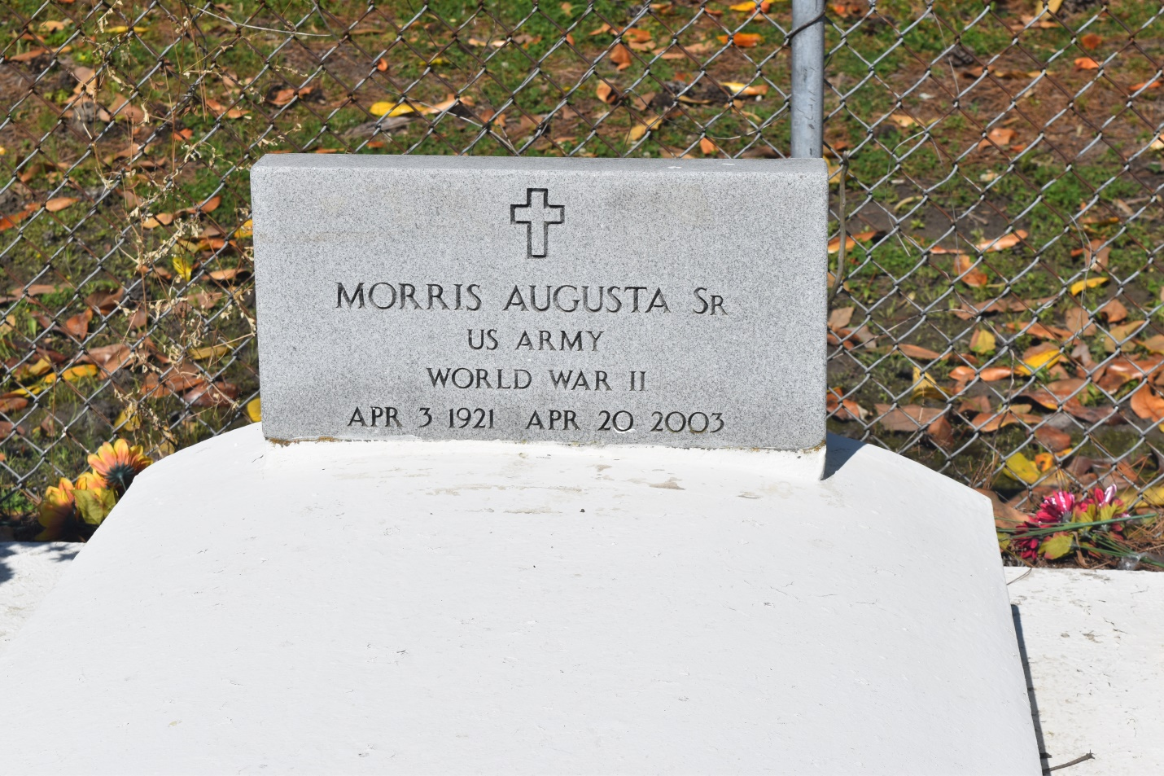

Morris Augusta, a retired handler at Celotex, died Sunday of cancer at Canon Hospice. He was 82. Mr. Augusta was a lifelong resident of Edgard.

Survivors include a son, Morris Augusta Jr. of Denver, Colo.; three daughters, Mary Pierre of LaPlace, Susan Morris of Austin, Texas, and Lula Lumar; a brother, Oscar Augusta; a sister, Adeline Bethancourt; his companion, Iris Mathieu; 11 grandchildren; and five great-grandchildren.

A Mass will be said Thursday at 11 a.m. at St. John the Baptist Catholic Church in Edgard. Visitation will begin at 8:30 a.m., with the rosary at 10 a.m. Burial will be in the church cemetery. The Baloney Funeral Home is in charge of the arrangements.

Times-Picayune, The (New Orleans, LA) - Wednesday, April 23, 2003

Contributed by Jane Edson