Zenobia (Meadoux) Augusta

February 11, 1919 – January 5, 2013

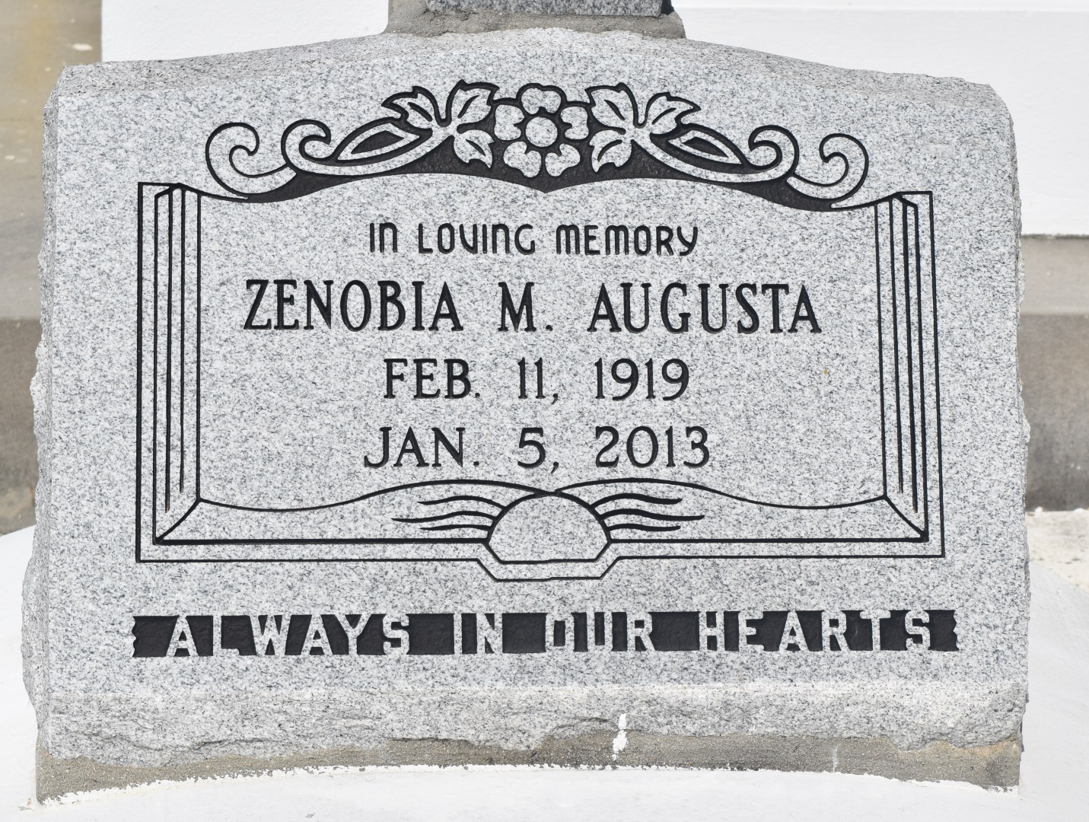

Zenobia Meadoux-Augusta, passed away on January 5, 2013 at the age of 93 years old. Wife of Oscar Augusta. Mother of Wanda Mitchell and the late Donald Lassere. Also survived by a host of sisters, nieces, nephews, grandchildren and other relatives and friends.

Funeral services will be held on Saturday, January 12, 2013 for 11:00 a.m. at St. John The Baptist Catholic Church located at 2361 Highway 18, Edgard, La. 70049. Visitation will be from 9:00 a.m. until time of service. Father Robustiano Morgia will be officiating. Funeral entrusted to The Baloney Funeral Home, LLC., 399 Earl Baloney Street, Garyville, La., 985-535-2540. Condolences can be expressed at [www.baloneyfuneralhome.com](http://www.baloneyfuneralhome.com/).

Times-Picayune, The (New Orleans, LA) - Friday, January 11, 2013

Contributed by Jane Edson