Bruce Martin Bailey

July 4, 1950 – August 8, 2010

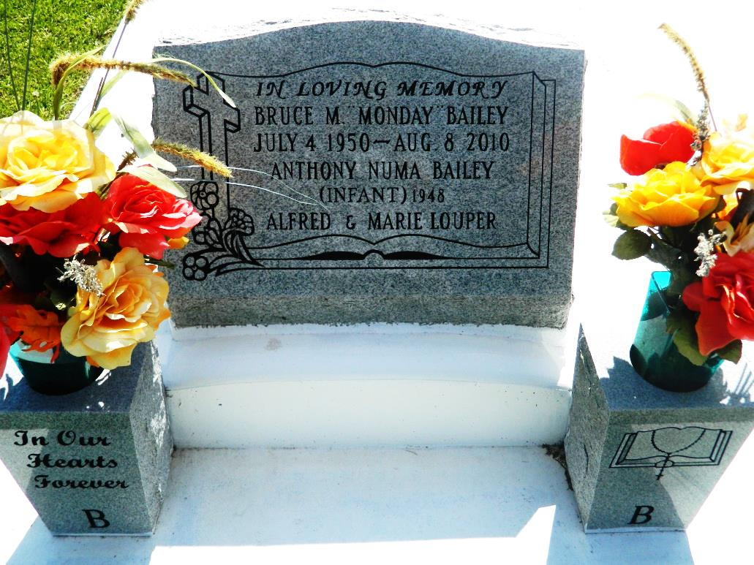

Bruce Martin "Monday" Bailey died on Sunday, August 8, 2010 of cancer (multiple myeloma) in River Parish Hospital at the age of 60. He was the son of Marjorie Sylvain Bailey and the late Numa Bailey, Jr. A long time resident of Edgard, Louisiana, he had also resided in Luling and LaPlace, Louisiana. Multi-skilled, he enjoyed working in varied family businesses.  
  
He was preceded in death by his father, Numa "Ga'son" Bailey, and brother, Anthony. He is survived by his devoted wife, Mary Singleton Bailey; mother, Marjorie Sylvain Bailey; son, Marlon Washington of Vacherie, LA; daughter, Brashonda Bailey of LaPlace, LA; stepchildren: Nicole Williams of LaPlace, LA, Christopher Williams of Paradis, LA and Deirdra Williams of Austin, Texas; 4 brothers: Wilton Bailey, Sr. and Perry Bailey, Sr. of Edgard, LA, Vernon Bailey, Sr. of LaPlace, LA, and Bertrand Bailey, Sr. of Baton Rouge, LA; 5 sisters: Veronica Alexander and Sharon Bailey of Edgard, LA, Marsha Bailey-Cantrelle of Garland, Texas, Varilyn Roussel of Waggaman, LA, and Shelia Bethancourt of Vacherie, LA; 11 brothers-in-law: Andrew Alexander of Edgard, Christohper Cantrell of Garland, TX, August Roussel of Waggaman, Errol Bethancourt of Vaherie, Ronald Baker, Jr. of New Orleans, LA. Somolon Singleton, Jr. of Des Allemands, LA, Leslie Singleton, Sr. of Fort Smith, Arkansas, Bryan Singleton, Sr. of Norco, LA, Anthony Jackson of Marrero, LA, Robin Jackson of Luling, LA and Mike Spalding of Littleton, Colorado; eight sisters-in-law: Cynthia Bailey and Kathie Bailey of Edgard, Robin Bailey of LaPlace, Renee Bailey of Baton Rouge, Alice Jackson of Marrero, Carol Jackson of Luling, Paula Spalding of Littleton and Janice Singleton of Des Allemands; two grandchildren: Ca'Marli Washington and Randy Nelson; uncles: Raymond Bailey and McKinley Borne of Edgard, LA; aunt, Cecile Alexander of Edgard; godchild, Tyson Roussel of Waggaman; dear friends: Aubrey Borne and Joseph Coulon; and a host of nieces, nephews, relatives and friends.  
  
A Mass of Christian Burial will be Saturday, August 14, 2010 at 11:00 a.m. at St. John the Baptist Catholic Church, Rev. Joel P. Cantones, Pastor), 2361 Highway 18, Edgard, Louisiana. Family and friends from surrounding churhces and schools and staffs of LSU Oncology Clinic, University Hospital, River Parish Hospital and Promise Hospital are invited to attend. Visitation 8:30 - 10:45 a.m. Rosary 10:00 a.m. Interment in be in the Church Cemetery.  
  
Baloney Funeral Home, Garyville, LA in charge of arrangements.

Times-Picayune, The (New Orleans, LA) - Friday, August 13, 2010

Contributed by Jane Edson