Porter Bailey

May 2, 1918 – December 13, 2001

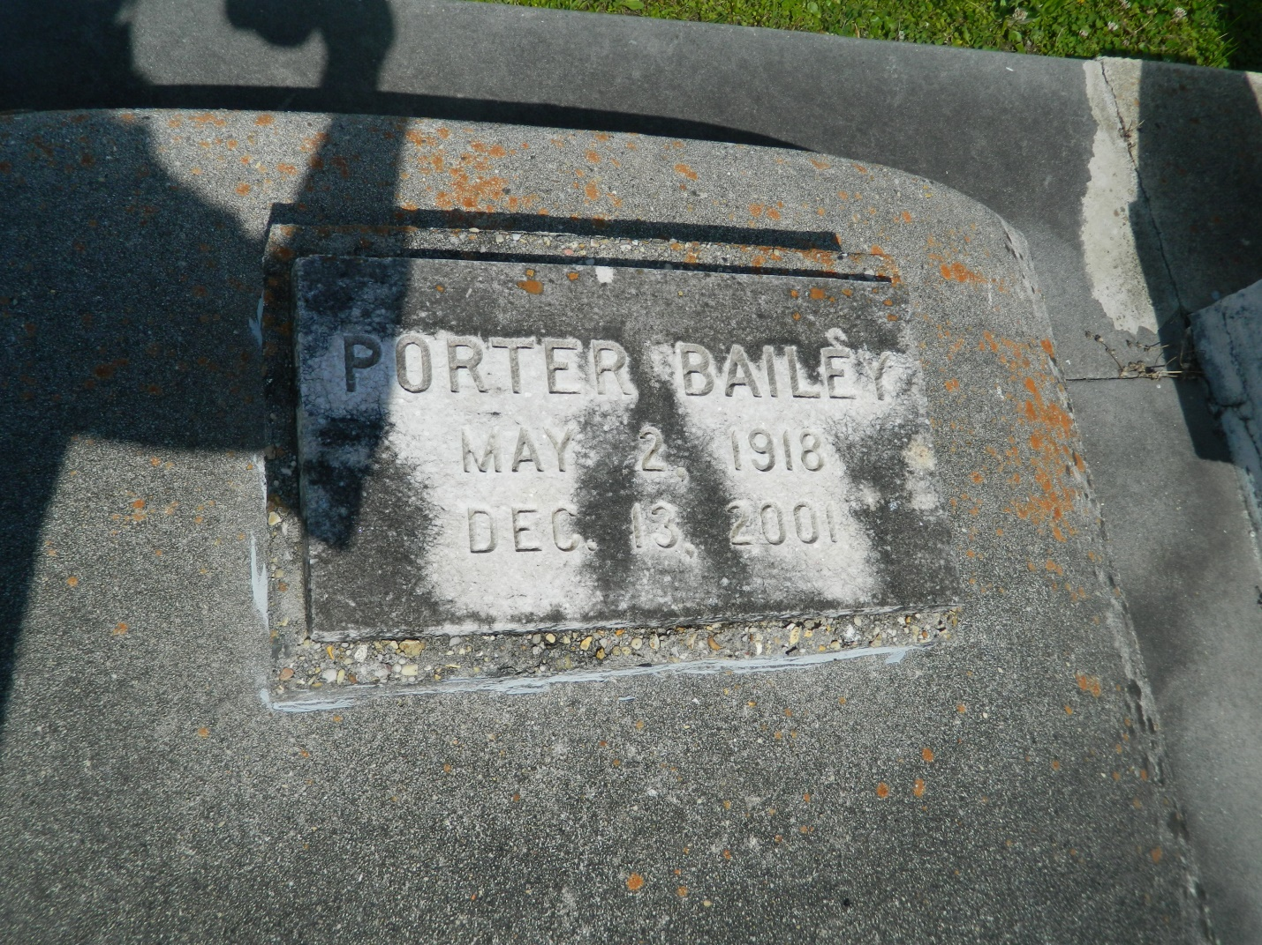

Porter Bailey, a retired laborer for Krauss Department Store, died Thursday at Life Care Hospital. He was 83. Mr. Bailey was born in Edgard and lived in New Orleans for the past 32 years. He worked for Krauss for 20 years and worked on a sugar cane plantation for 30 years.

Survivors include a son, Earl John Bailey Sr., and a grandchild.

A Mass will be said Wednesday at 10 a.m. at Our Lady of Guadalupe Catholic Church, 411 N. Rampart St. Visitation will begin at 9 a.m. Burial will be in St. John the Baptist Church Cemetery in Edgard. D.W. Rhodes Funeral Home is in charge of arrangements.

Times-Picayune, The (New Orleans, LA) - Tuesday, December 18, 2001

Contributed by Jane Edson