Odeal V. Barre

February 14, 1917 – December 19, 2008

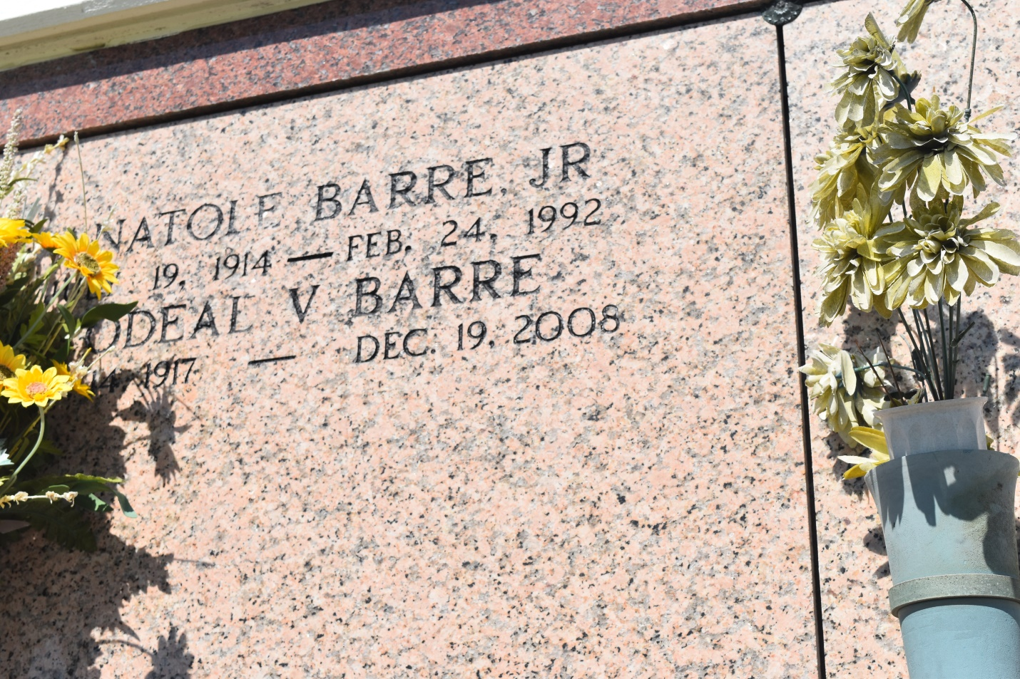

Odell V. Barre on Friday, December 19, 2008, at St Charles Hospital in Luling at 1:00 p.m. Beloved son of the late Anatole and Leona Matthews Barre. Brother of the late Priscilla Barre, Norma B. Burke and Anatole Barre Jr. all of Lucy, Albium B. Duhe of Reserve, Celestine B. Williams, Jane B. Merrick and Josephine B. Legaux all of New Orleans. Beloved and devoted uncle and great uncle of Penny Goudia of Lucy, Anthony Goudia of LaPlace, Chenell G. Brown and Felton L. Goudia Jr. both of Houston. Also survived by a host of nieces, nephews, cousins, other relatives and friends. Age 91 years. A native and resident of Lucy.  
  
Visitation and services were held at St John the Baptist Catholic Church in Edgard on Tuesday, December 23. Interment at St. John the Baptist Catholic Cemetery in Edgard.

L'Observateur (La Place, LA) - Wednesday, December 24, 2008

Contributed by Jane Edson