Antoine Bartholomew Jr.
May 25, 1956 – September 17, 2008

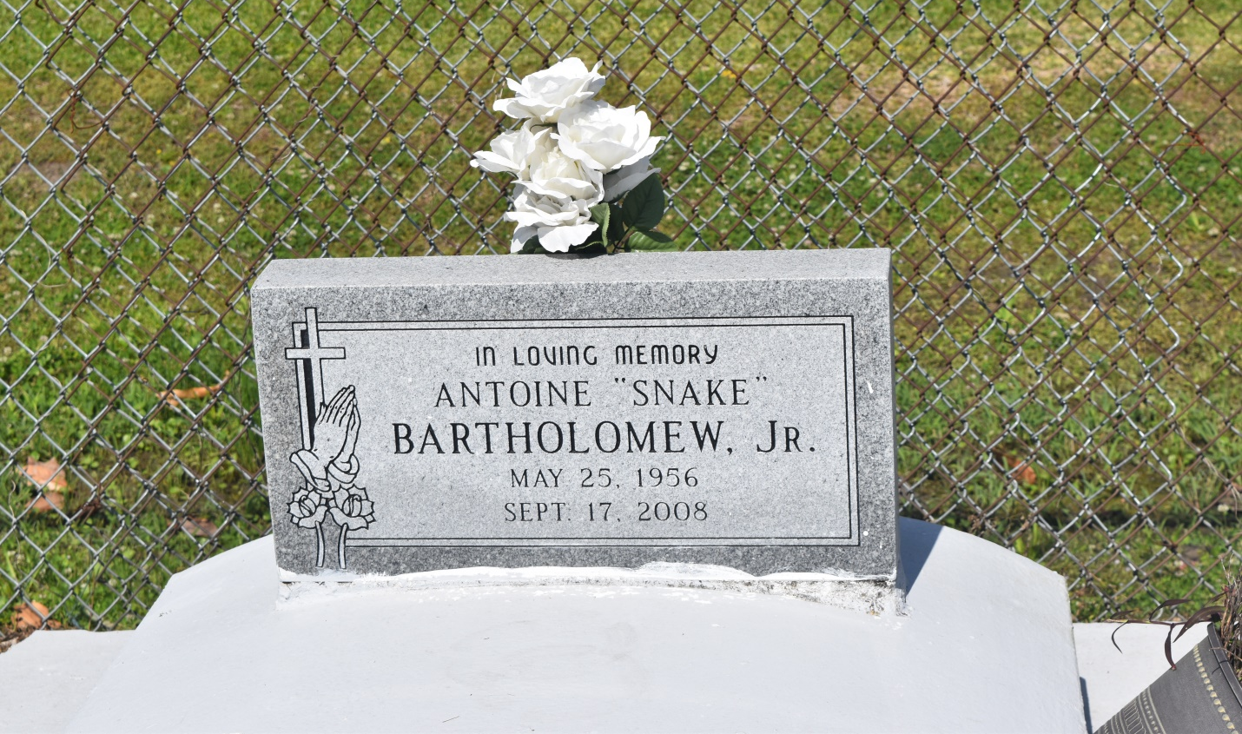

Antoine "Snake" Bartholomew, Jr., a native and resident of Edgard, La. on Wed., Sept. 17, 2008, at Our Lady of the Lake Hospital. Son of Wilhelmina and Antoine Bartholomew, Sr. Brother of Darlene, Bonnie Bartholomew, Tonja Wilson (Elton), Timolin Johnson (Hugh), all from Houston Tx., Ray Bartholomew (Stephanie), Edgard, La., Morell Bartholomew (Sharron), Harvey, Jonah Bartholomew (Tomeka), Edgard, La. Devoted nephew of Flora Champagne and Gilbert Bartholomew. Also survived by a host of nieces, nephews, cousins and friends. Age 52yrs.
Relatives and friends of the family, also priest and parishioners of St. John the Bapt. Catholic Church, Class of '74 2nd Ward H.S., are invited to attend a Mass of Christian Burial on Fri., Sept. 19, 2008 at 11:00AM from the St. John the Bapt. Catholic Church, Edgard, La. Father Joel Cantones, Celebrant. Recitation of Rosary 10:00AM. Visitation at the church after 9:00AM. Interment church cemetery.
The Baloney Funeral Home, LLC., 399 Earl Baloney Dr., Garyville, La., 985-535-2540 In charge of arrangements

Times-Picayune, The (New Orleans, LA) - Friday, September 19, 2008
Contributed by Jane Edson

