Ellis Joseph Becnel Jr.

1969 – May 25, 2018

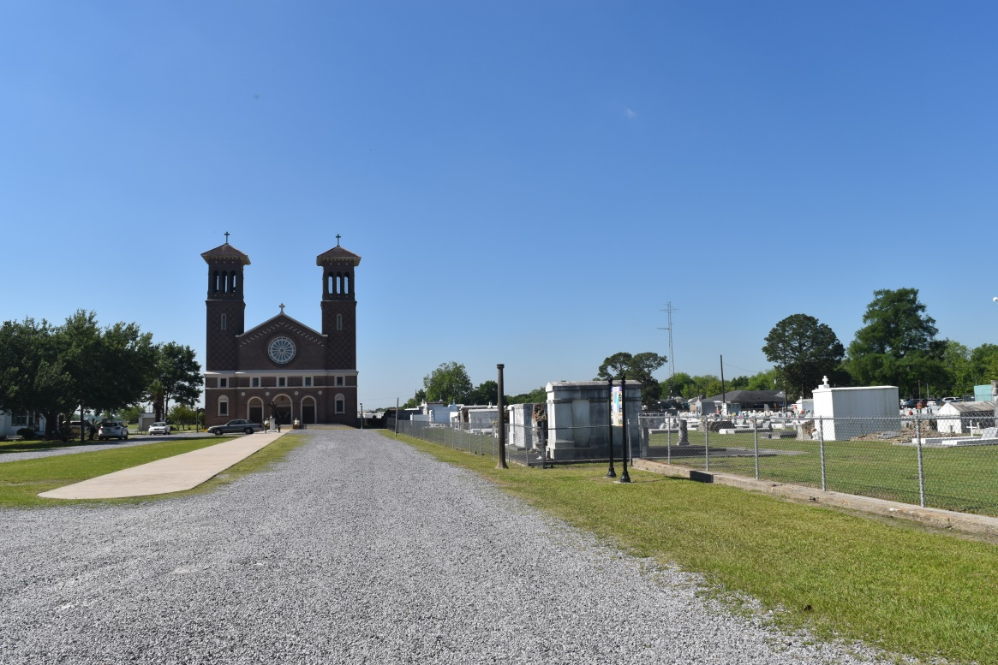

Ellis Joseph Becnel Jr. ( Po-No) of Edgard, La. on Friday May 25, 2018 at Chabert Medical Center departed this life. Son of the late Clancy Ellis Becnel and Gladys Steib Becnel. Husband of Latasha Chopin Becnel. Father of Jada, Janada, Jalacia and Javahea Becnel. Grandfather of Cayden Becnel . Survived by aunts, uncles, other relatives and friends. Son in law of Christine Chopin Gros and Joseph Gros and Ward Dupard. A native and resident of Edgard, La. Employees of C B& I , Lofton Security, West St. John Class of "89", Allied Universal Security, Cabela, and V-F Factory are invited to attend a mass of christian burial on Saturday June 9, 2018 at 10:00 am from St. John the Baptist Catholic Church 2349 Hwy 18 Edgard, La. Father Robustiano Morgia celebrant. Visitation at the church after 8:00 am. Recitation of the rosary at 9:00 am. Interment church cemetery. Final care entrusted to Treasures of Life Funeral Services.

Treasures of Life online obituary (accessed 6/19/2018)