Anne (LeBlanc) Berthelot

unknown – June 25, 2018

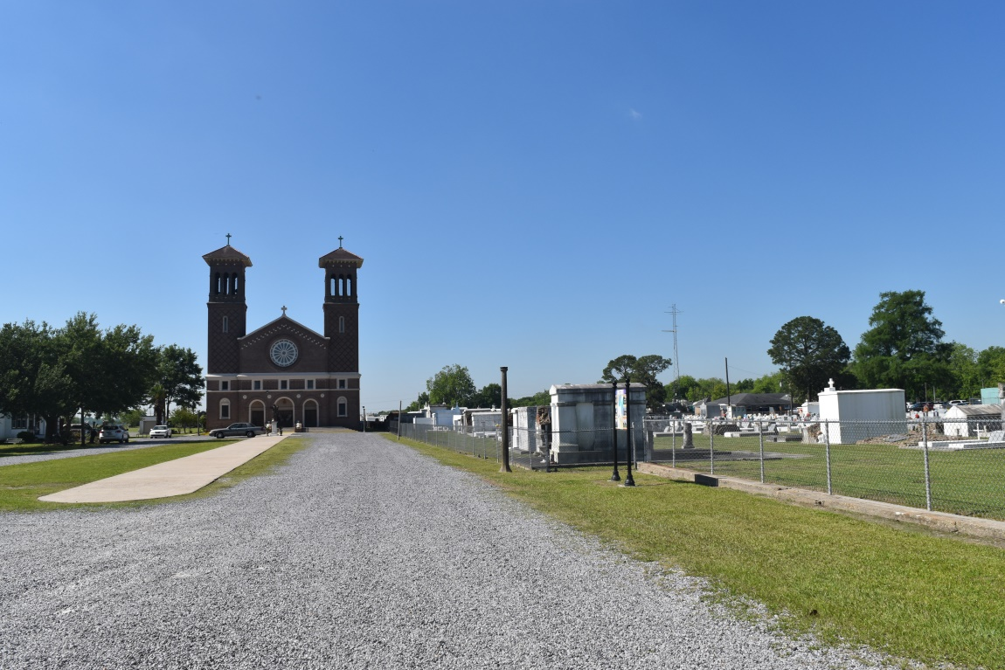

Anne LeBlanc Berthelot passed away peacefully on Monday, June 25, 2018. She was preceded in death by her husband, Albert Berthelot; parents, Charles and Corinne LeBlanc; siblings, Jessie LeBlanc, Steven LeBlanc, Bruno LeBlanc, and Evert LeBlanc . Survived by two children, Charles Lanny Berthelot and Kathy Olivier; two grandchildren, Susan Olivier Paniello and Julie Olivier; and five great grandchildren.

The family is very grateful to Angela Reynolds, friend and caregiver, the staff of Chateau St. James Nursing Home and the angels from Notre Dame Hospice.

Visitation will be held at Millet-Guidry Funeral Home, 2806 W. Airline Hwy. LaPlace on Saturday, June 30, 2018 from 10:00 a.m. to 12:00 p.m. followed by the Funeral Service at 12:00 p.m. Interment in St. John the Baptist Cemetery, Edgard, LA.

Millet-Guidry Funeral Home online obit (accessed 6/28/2018)