Charles Lanny Berthelot

October 17, 1939 - April 30, 2019

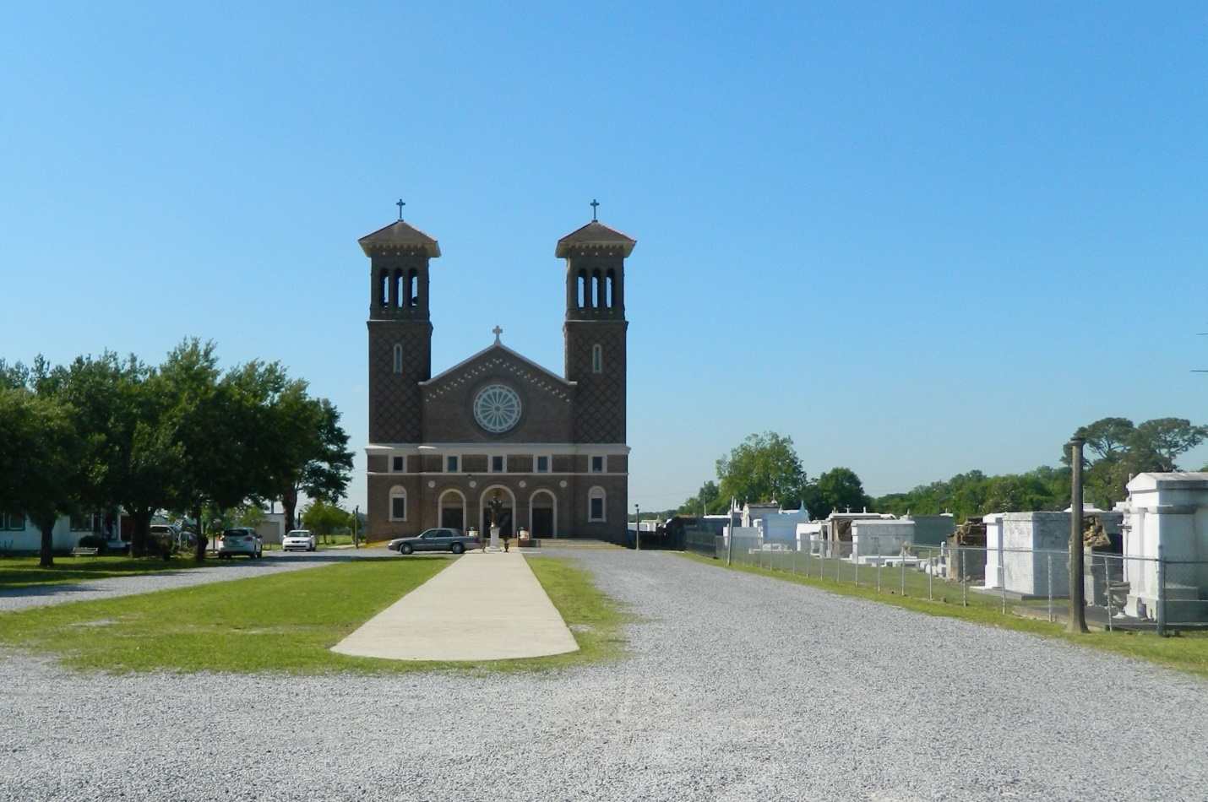

Charles Lanny Berthelot passed away peacefully on Tuesday, April 30, 2019. Loving and devoted son of the late Albert J. Berthelot and Anne LeBlanc Berthelot. Brother of Kathy Berthelot Olivier (late Daniel Olivier). Uncle of Susan Olivier Paniello and Julie Anne Olivier. Great uncle of Elizabeth, Samuel and Christopher Paniello and Mason and April Klein.

He was a retired Louisiana Legislative Auditor. Graduate of Edgard High School. Served in the

U. S. Air Force and received his accounting degree from Nicholls State University. An avid sports fan, especially of LSU and the New York Yankees. Loving and kind, he was a true Christian. He will be sadly missed by all who knew him.

Preceded in death by his grandparents Edward and Muriel Bossier Berthelot and Charles and Corine St. Germain LeBlanc.

Relatives and friends are invited to attend the Funeral Service at Millet-Guidry Funeral Home, 2806 W. Airline Hwy., LaPlace on Friday, May 3, 2019 at 11:30 a.m. Visitation will be held from 10:30 a.m. until 11:30 a.m. Interment in St. John the Baptist Cemetery, Edgard.

Millet-Guidry Funeral Home, LaPlace, LA (accessed 5/2/2019)