Ruby (Premeaux) Berthelot

Abt. 1924 – October 30, 2018

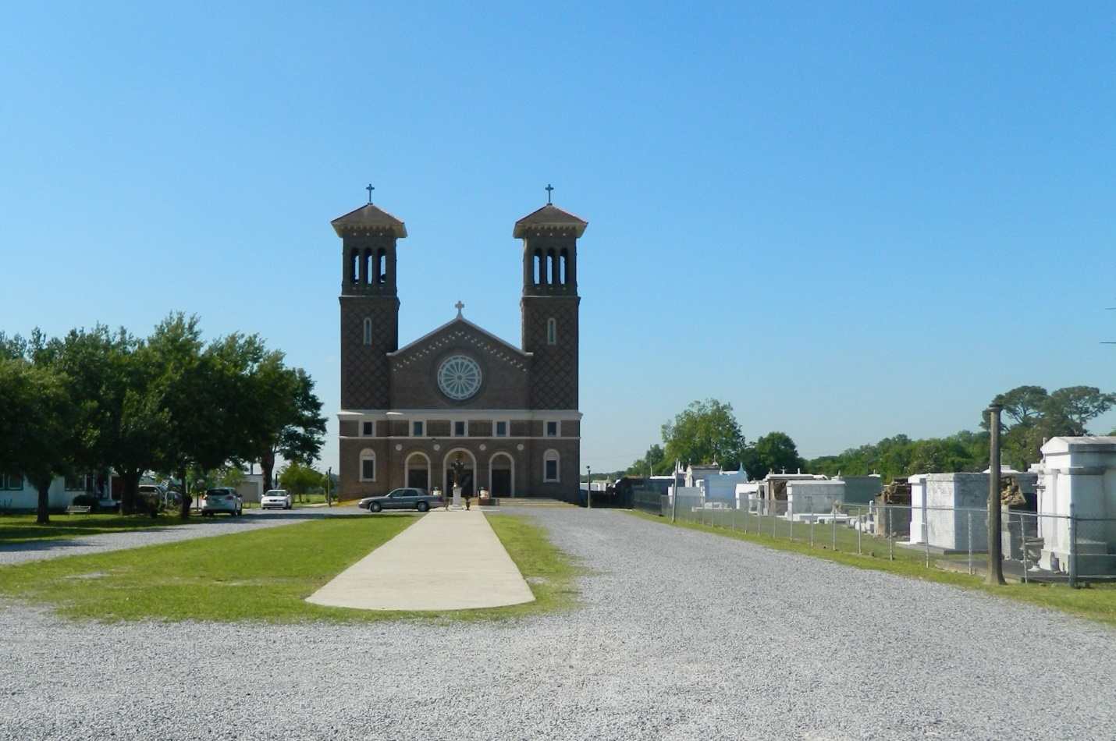

Ruby Premeaux Berthelot, age 94, passed away peacefully at Chateau de Notre Dame Home in New Orleans on Tuesday, October 30, 2018. She was born in Gueydan, Louisiana to the late Meance and Gadra Vincent Premeaux and was preceded in death by her six siblings. She was married to the late Felix F. Berthelot for 57 years and was a long time resident of Reserve and member of St. Peter’s Catholic Church. She was a school teacher in St. John the Baptist Parish schools and St. Peter’s Parochial School for over 25 years. She is survived by her two daughters, Charlotte Berthelot Garst (John) and Aimee Berthelot Place; son, Michael Berthelot (Deidre); six grandchildren, Carrie Nelson, Michael Garst, Genevieve Matherne, Danielle Guzzardo, Derek Berthelot, David Place; and four great grandchildren.

Visitation will take place at St. Peter’s Catholic Church, 1550 Hwy 44, Reserve on Friday, November 2, 2018 from 11:00 a.m. followed by the Funeral Mass at 12:00 p.m. Interment immediately following in St. Peter’s Church Cemetery.

In lieu of flowers, memorial donations may be made to St. Jude Children’s Research Hospital.

Millet-Guidry Funeral Home, LaPlace, LA (accessed 11/1/2018)