Luis Jose Bethancourt
5 May 1750 - 14 May 1826

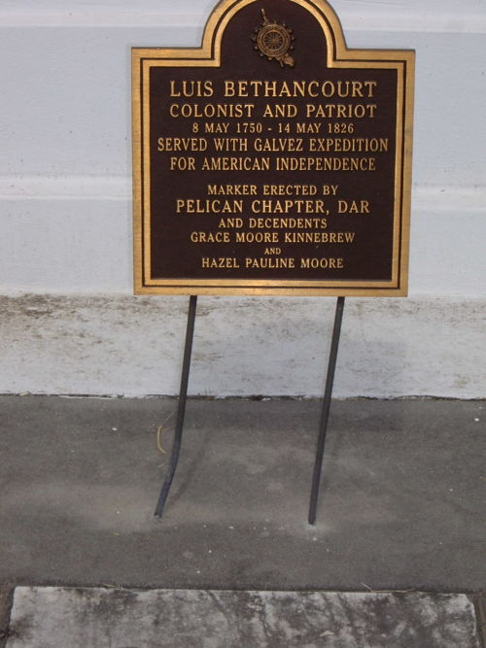
Photo courtesy of WikiTree

Information taken from funeral record, St John the Baptist Church, Edgard, LA, Funeral Register 3, page 12. Notes that he died at age 81 in New Orleans at the home of his son-in-law, Mr. Ruiz. Also notes that Louis was a native of Guia, Canary Islands, son of late Nicolas Bethancourt and Rita Ramos, and has been living in the US for 45 years. He served as sacristan of the church. Interment was in St John the Baptist Cemetery, Edgard, LA, on 15 May 1826.
Contributed by Dwayne Montz
**
The 1826 funeral note by the church already mentioned Luis' son-in-law, "Mr. Ruiz", with whom he was living in New Orleans when he died that year. 54 years later, that same son-in-law's wife, Luis' actual daughter, "Marie"/Mrs. Pierre Manuel Ruiz, the former Miss Lucie Maria de Bethancourt (aka. María-Lucia Betancourt), was then herself a 77 year old widow living with her own adult son Edgard Ruiz. Luis' daughter Marie told the 1880 US Census taker in New Orleans, Louisiana that her mother and father (Cathalina née Calcines Bethancourt & Luis Jose Bethancourt) were born in "St Cruz, Sp." Simplified for practicality, she told the enumerator just the province and country (likely all he wanted to know), like saying "New England in America" to answer "where were your parent's born?" to a foreigner who might not know where individual U.S. states are within this country, let alone their knowing a foreign town or tiny village anyway. -- When Marie née Bethancourt Ruiz's dad Luis died & was buried in Edgard, Saint John the Baptist Parish, Louisiana, in 1826, his birthplace was apparently written in the church record as "Guia."
"Guía de Isora, Provincia de Santa Cruz de Tenerife, Islas Canarias, Spain."
Luis's family, the family into which Cathalina Calcines married circa 1800, the Bethancourts, were prominent in the Canary Islands, to say the least:
"Bettencourt is a surname and noble family of Norman French origin. The head of the family in the 14th century, Jean de Béthencourt, organized an expedition to conquer the Canary Islands, resulting in his being made King of the Canary Islands. Though the royal title would be short-lived, it allowed the family to firmly establish itself afterwards in the Azores and Madeira islands. The family is one of the most expansive and established families of the Portuguese nobility, as well as the Spanish nobility."
"Under the reign of Carlos III, Spain recruited more than 3,000 colonists from the Canary Islands to settle the sparsely populated colony of Louisiana between 1777 and 1782. Referred to as isleños, meaning 'Islanders,' these consummate survivors formed the vanguard of Spain's colonization efforts. Following the French and Indian War, the colony was divided into two sections. All that territory lying west of the Mississippi River and the Isle of Orleans, including the fledgling town of New Orleans, was ceded to Spain. All of the former French territory lying east of the Mississippi River was ceded to Great Britain." Continue reading the in-depth article on the losislenos dot org forward slash history website.
"Origins of the Isleños - Beginning in the fourteenth century, the kingdoms of the Iberian Peninsula, predating the establishment of the Kingdom of Spain, began searching for gold and other valuable resources beyond Europe. King Henry III of Castile commissioned Jean de Béthencourt to explore, conquer and colonize the Canary Islands which he began with the conquest of the island of Lanzarote in 1402. Béthencourt had identified cochineal, an insect which yielded a valuable crimson-red dye, in the Canaries. The conquest of the Canaries continued throughout the remainder of the fifteenth century, finally concluding with the conquest of the island of Tenerife in 1496."
By William de Marigny Hyland. Published October 5, 2019 (Edited November 17, 2021
**
Excerpts from "Remembered Ally Who Helped America Win the Revolution: Bernardo de Galvez's involvement may not have been altruistic, but his contributions made a difference nonetheless" by Erick Trickey in Smithsonian magazine, 13-Jan-2017:
"Two years into the Revolutionary War, as the Americans hunted for any advantage in their war for independence, they cultivated a daring young Spaniard as an ally: the governor of Louisiana, Bernardo de Galvez.
"In April 1777, George Morgan, the commander at Pittsburgh's Fort Pitt, sent a flotilla down the Ohio and Mississippi rivers to New Orleans carrying a letter to Galvez, offering to trade with Spain and asking for aid in case the Americans decided to attack the British in Florida. The American ships sailed back up the Mississippi River that August filled with ammunition, arms, and provisions. "I will extend…whatever assistance I can," Galvez responded, "but it must appear that I am ignorant of it all."
"First by stealth, then by open warfare, Galvez became a key ally of the American Revolution. But he's been long forgotten, eclipsed by the Marquis de Lafayette and other foreign friends of America.
"For eight years, Galvez served as governor of Spanish Louisiana, the vast territory acquired from France in 1762, which reached from the Mississippi River west to the Rocky Mountains and from New Orleans north into present-day Canada. Galvez allowed shipments of weapons, medicine and fabric for military uniforms to be sent to the Continental Army via the Mississippi. In 1779, when Spain declared war on England, Galvez attacked British West Florida, winning it back for his king and indirectly benefiting the Americans by forcing the British to fight on two fronts.
"Yet Galvez was no revolutionary. He wasn't helping the Americans out of sympathy for their cause. Siding with the Americans advanced the interests of the King of Spain, England's longtime rival, in a worldwide great-power conflict. Because of that, American history takes less note of his strategic alliance. It took until 2014 for Galvez to get official recognition from the United States, when he was named an honorary U.S. citizen by Congress.
"...Dispatched to New Orleans as a colonel in June 1776, Galvez was appointed governor of Louisiana on New Year's Day 1777 at age 30. His youthful boldness and his marriage to a Creole beauty, Felicie de St. Maxent d'Estrehan, charmed the colonists.
"...After the war, Carlos III showered Galvez with honors. He gave Galvez permission to use the phrase "Yo Solo," or "I Alone," on his coat of arms, in "memory of the heroic action in which you alone forced the entrance of the bay." In 1785, he named Galvez to succeed his late father as viceroy of New Spain. Galvez governed Spain's American possessions for only a year and a half; he died of yellow fever in Mexico City in November 1786 at age 40.
"Spain ceded Louisiana to France in an 1801 treaty, but Napoleon sold it to the United States in 1803, doubling the new nation's size. The Spanish ceded Florida to the U.S. in 1821.
"...In time, Galvez has gotten his due. In the 1820s, Mexico named Galveston, Texas, after him. And on December 16, 2014, President Obama signed the congressional resolution that named Galvez an honorary U.S. citizen, an honor given only to eight foreign nationals, including wartime allies Lafayette and Winston Churchill. The resolution called Galvez a hero of the Revolutionary War "who risked his life for the freedom of the United States." Few may remember him, but the legacy of one of the Revolutionary War's most dashing, daring allies endures."
Search with the title to read the whole article with key bold military moves that protected trade on the Mississippi River with victories at Baton Rouge and Natchez and Mobile; across the Gulf of Mexico at Pensacola, Florida, his Spaniards got the British out of Florida for good. He even directly effected famous battles as far as at Chesapeake and Yorktown, and Spain's supply ships in Haiti. Consider even just that "Galvez continued to allow supplies to move up the Mississippi to Pennsylvania—an important back door to the battlefront, since the British had blockaded East Coast ports."

