Debbra Ann (Alexander) Borne

March 15, 1950 - December 2, 2022

 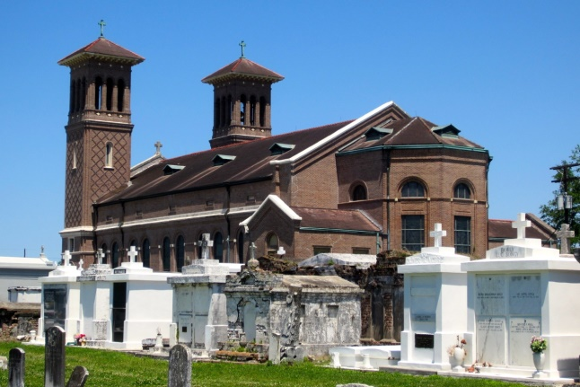

  Debbra was born on March 15, 1950, to the union of the late Perkin and Ethel Alexander of Edgard, LA. On Friday, December 2, 2022, God dispatched his angels to call Debbra home to meet her Heavenly Father. She peacefully departed her earthly life and gained her external wings surrounded by family.  
 Debbra confessed her belief in the Lord Jesus Christ in 1979 at First Assembly of God in New Orleans. She attended The Word Church in Denver, CO, where she became ordained. Debbra also attended The Potter’s House of Denver, where The State of Colorado Corrections Board rewarded her for her work in prison ministry. Debbra served her last days as a member of Church of God Ministry in Gretna, under the direction of Pastor Tom Kerry.  
 Debbra was employed at Dow Chemical (Union Carbide) until retirement. She later worked in real estate as a realtor at Gautreaux Real Estate, Executive Realtor, and most recently at Supreme Realtors. Debbra loved traveling, ministering, reading her Bible, and spending time with her grandchildren.  
 Debbra was preceded in death by her parents, Perkin J and Ethel Weber Alexander; brothers, Warren, Perkin Jr, Milton, Ervin Sr., and Andrew Alexander; sisters, Sedonia Bailey, Ethel Lewis, and Lucille Brown; nephews, Demond Jackson, Isaac Jackson, Jr., and Ashton Savage; aunts, Eloise Fiffie and Rose Alexander; brother-in-law’s, Manuel Bailey and James Louis.  
 Debbra leaves to cherish her memory, her devoted husband Bruce Borne; children, Chad (Patrice) Oubre Sr,, Lamoine Oubre Sr., and Brittany (Brandon) Anderson; 11 grandchildren and 1 great-grandchild; siblings, Carolyn Wallace, Gloria Jackson, and Darnell (Isaac, Sr) Jackson; sister-in-law, Veronica Alexander; godchildren, Nedra Bailey and Dwight Roussell, Jr.; and a host of nieces, nephews, relatives, and friends.  
 A celebration of life honoring Debbra Ann Borne will be held on Wednesday, December 14, 2022, at New Wine Christian Fellowship, 1929 W Airline Hwy, Laplace, LA 70068. Visitation begins at 9 AM and the service begins at 10 AM. Entombment to follow at St.John the Baptist Catholic Church Cemetery. Final care and professional services entrusted to Treasures of Life Funeral Services, 315 E. Airline Hwy., Gramercy, LA 70052.

Treasures of Life Funeral Services, Gramercy, Louisiana