Agnes (Thomas) Borne-Farnell

April 23, 1946 – July 1, 2000

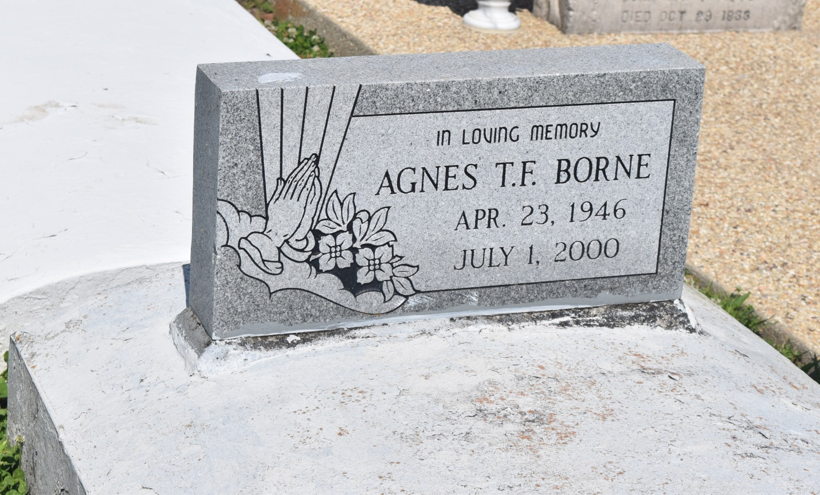

EDGARD - Agnes Farnell Borne, 54, a native of Edgard and resident of LaPlace, died July 1. She was the wife of David Borne, by first marriage, the wife of John Farnell Jr., by second marriage, and mother of Nirla Farnell and Tanipha Johnson.  
  
She was also the daughter of the late William Sr. and Irene Thomas and sister of Wilberine Anderson, Amy Alexander, Wilhelmina Bartholomew and the late Augustine, Raymond, William, Wilfred, Wilbert and Ervy Thomas.  
  
She is also survived by seven grandchildren.  
  
Services were July 5 at St. John the Baptist Catholic Church, Edgard, with interment at the church cemetery.

L'Observateur (La Place, LA) - Saturday, July 8, 2000

Contributed by Jane Edson