George Joseph Borne, Jr.

May 27, 1932 - July 6, 2019

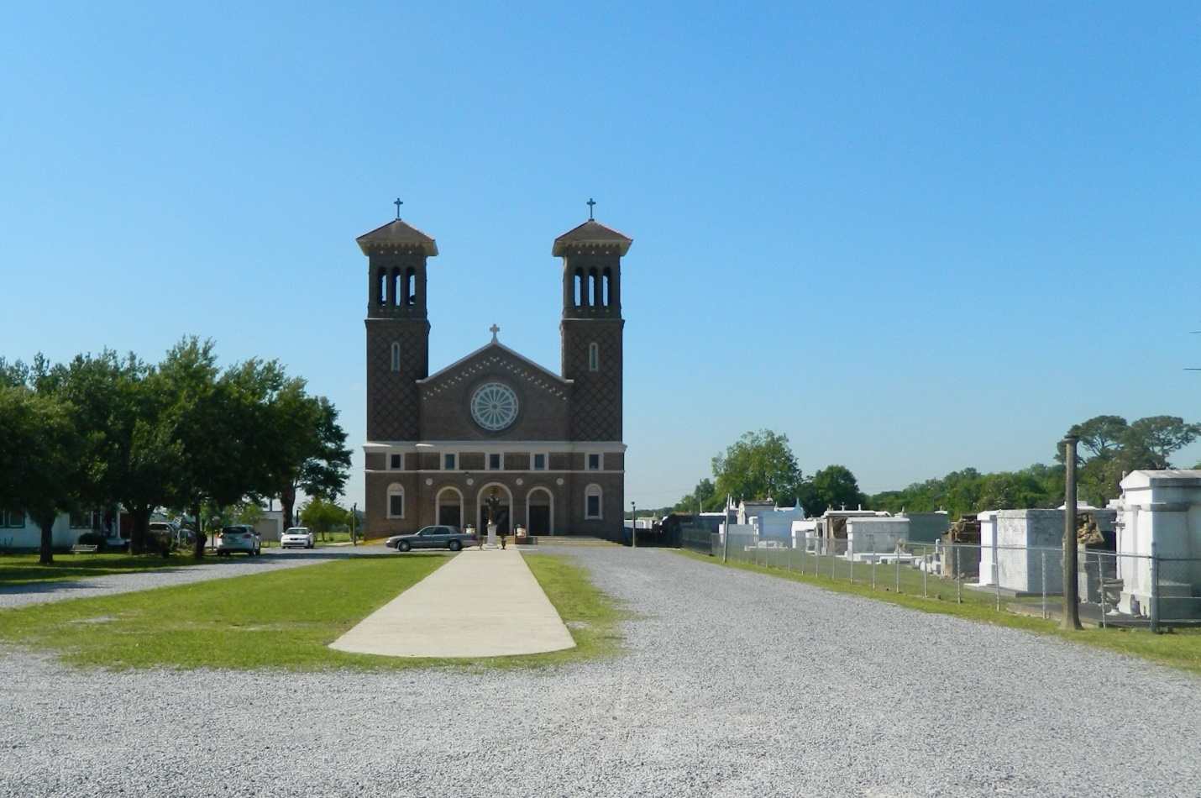

George Joseph Borne, Jr. passed away on Saturday, July 6, 2019 at the age of 87. He was a resident of Hahnville, LA.

He was preceded in death by his parents, George Joseph Borne, Sr. and Rose Dufrense Borne; brother, Farrell; and sister, Juanita.

Mr. Borne better known as “PaPa George” was the beloved husband of Beverly Becnel Borne. Devoted father to his children, Rhonda Rogers (Randy), George Joseph Borne, III (Landa) and Brenda Jones (Randall). Grandfather of Ridge Rogers (Taylor), Brittney Conway (Chris), Andrew Boudreaux (Shana), Maddie Tregre (Cameron), Megan Boyer (Brian), Mallory Borne (Dominick) and Shaney Trepagnier. Beloved brother of Blanche Borne (the late Hilton), Myrle Borne, Ralph Borne, Sr. (Mona) and Myrlene Thibodeaux (Paul). Also survived by 9 great-grandchildren and many nieces and nephews.

PaPa George served in the United States Army for the Korean Conflict in 1953/ 1954. He retired from Monsanto in 1987. He was a member of Holy Rosary Church in Hahnville, Hahnville Fire Department, and German Coast Farmer’s Market, where he sold his famous hog head cheese and other delicious foods he loved to cook. While cooking in his backyard kitchen, he would often sing karaoke. He liked the oldies but goodies such as Hank Williams Sr. and Ernest Tubb, but his favorite was Willie Nelson.

The family would like to thank DaVita for the love shown to PaPa George over the last two years. Also, to Dr. Christopher Paris who he highly admired, loved and respected.  
In lieu of flowers, the family would like donations made in his name to DaVita Kidney Foundation.

Relatives and friends are invited to attend the Funeral Mass at St. John The Baptist Church Edgard, 2349 Highway 18, Edgard, LA on at Thursday, July 11, 2019 at 11:00 a.m. Visitation at the church from 8:30 a.m. to 11:00 a.m. Interment in St. John the Baptist Church Cemetery, Edgard.

Millet-Guidry Funeral Home, LaPlace, LA (accessed 7/9/2019)