Lonnie Joseph Borne

April 20, 1951 – January 15, 2013

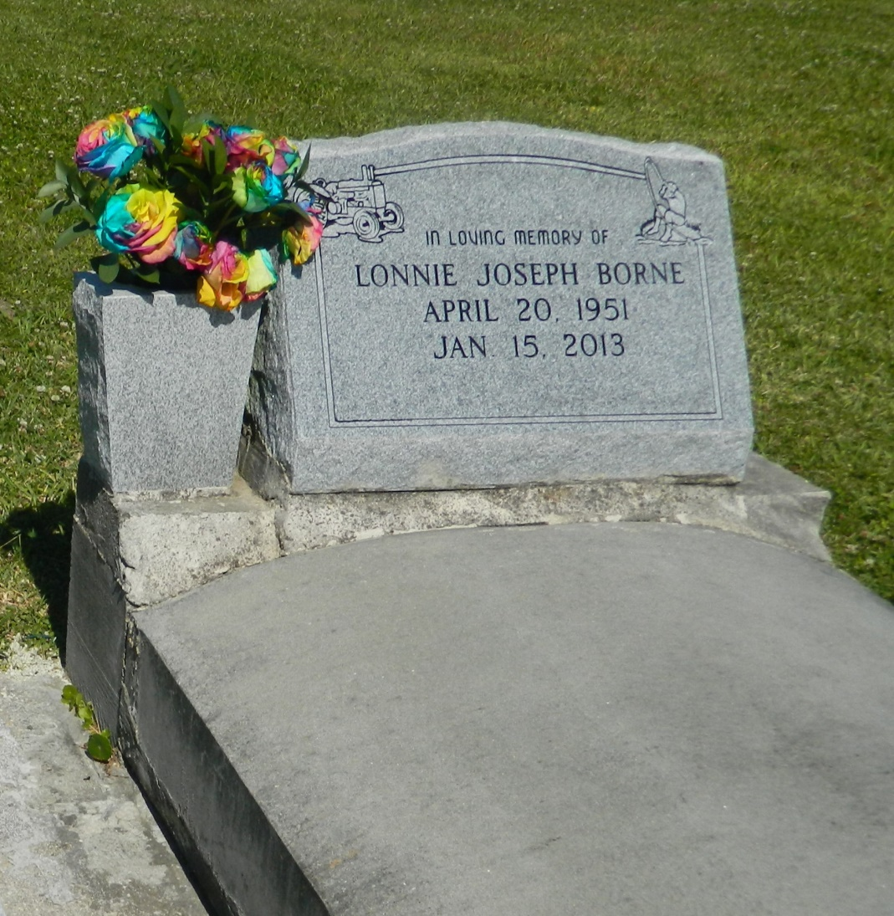

LONNIE JOSEPH BORNE on Tuesday, January15, 2013 at his home in Edgard, LA. Son of Claire Borne and late Aurbrey Borne, Sr. Husband of Diana Woods and lifelong-companion of Wanda Shepherd. Father of Lonnie Woods, Kentrell, Sr., Ashley, Ashton, Kim, Latroy, Requita, Latrice, Monique, the late Dontrell and Terence Shepard. Step Father of Keith, Micheal, Ron and Anthony Shepard. Brother of Diana Dumas, Aurbrey Borne, Jr. (Cynthia), Micheal Borne (Cheryl), Stella Borne, Dafney Borne Washington (Roger), Ricki Borne (Dorian), Claudia Bailey, Barbara Borne Lewis (David), and the late Danny Borne. Godfather of Lacey Bailey, LaDane Borne and the late Micheal Borne, Jr. Also survived by 11 grandchildren and a host of nieces, nephews, cousins, other relatives and friends. Age 61 years. A native and resident of Edgard, LA.  
 Relatives and friends of the family, also priest and parishioners of St. John the Baptist Catholic Church and all neighboring churches are invited to attend the Funeral Mass at St. John the Baptist Catholic Church, 2361 Highway 18, Edgard, LA on Wednesday, January 23, 2013 at 11:00 AM. Father Robustiano Morgia, Celebrant. Interment St. John the Baptist Cemetery, Edgard, LA. Visitation at the above named church from 9:00AM until Mass time.  
 SERVICED BY ROBOTTOM

Times-Picayune, The (New Orleans, LA) - Sunday, January 20, 2013

Contributed by Jane Edson