Monita Maria Bossier

August 18, 1970 – December25, 2002

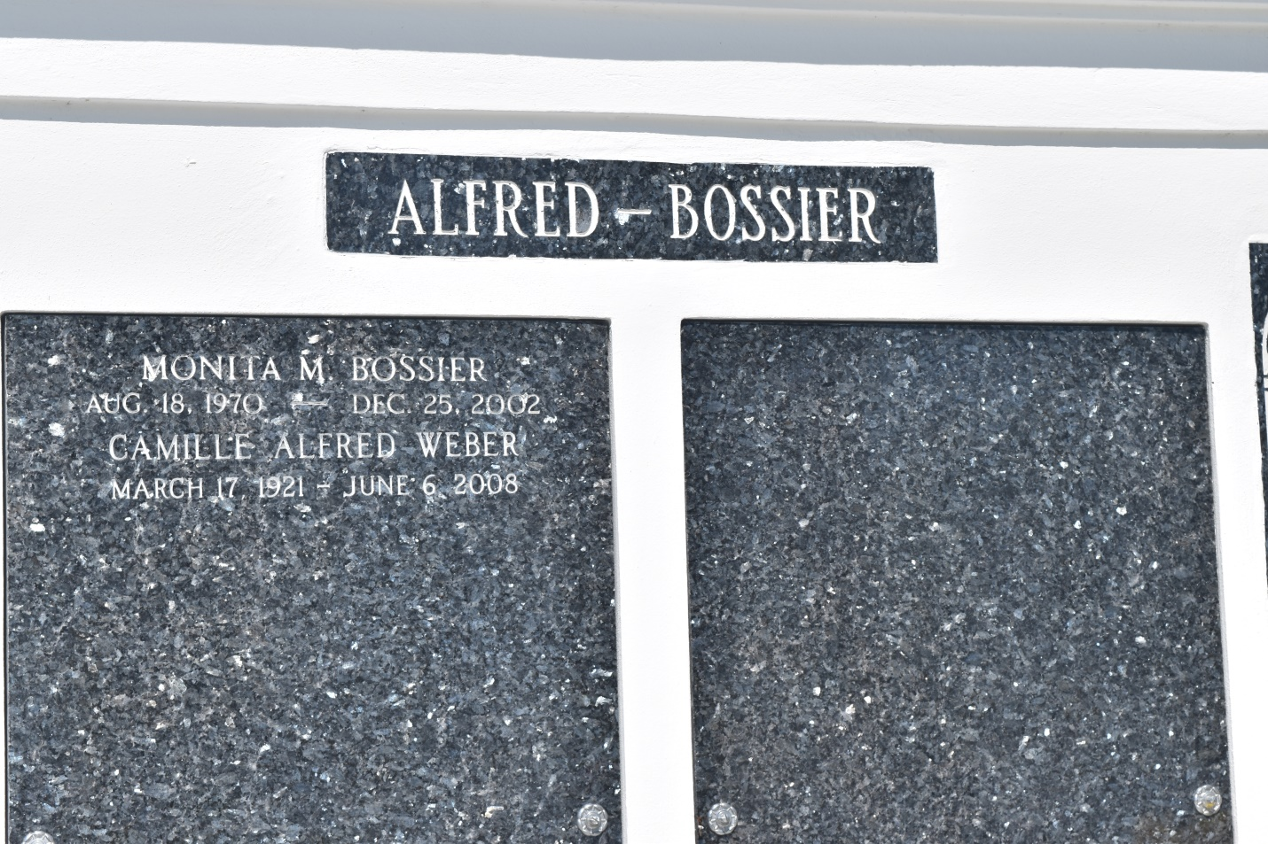

Monita Maria Bossier, a quality control representative for Ford Motor Co., died Wednesday of undetermined causes at her home. She was 32. Ms. Bossier was born in New Orleans and lived in Detroit for more than 30 years. She graduated from Redford High School and attended DeVry Institute of Technology.

Survivors include her father, Ronald Merritt of Benton Harbor, Mich.; her mother, Paula Bossier Miller; two sisters, Raequel and Phoebe Miller; and grandparents, Camille Weber of New Orleans and Georgia and Paul Merritt of Benton Harbor.

A Mass will be said Monday at noon at St. John the Baptist Catholic Church, 2361 Louisiana 18, Edgard. Visitation will begin at 10 a.m. Burial will be in St. John the Baptist Cemetery. Majestic Mortuary is in charge of arrangements.

Times-Picayune, The (New Orleans, LA) - Sunday, December 29, 2002

Contributed by Jane Edson