Julius Boudoin Sr.

Abt. 1946 - October 9, 2018

* 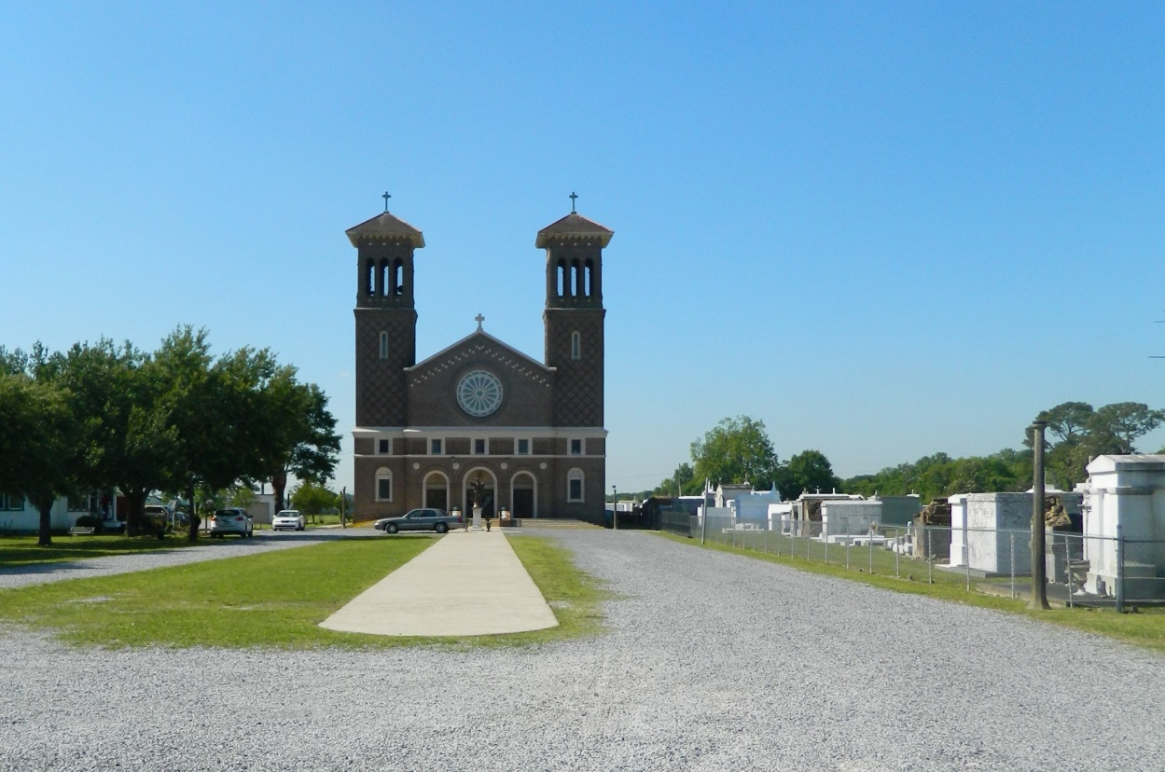

Julius Boudoin Sr. at the age of 72 yrs departed this earthly life and entered into eternal rest on Tuesday, October 9, 2018 at his residence in Wallace, LA surrounded by his relatives. Son of the late Louvertha Jarrow Boudoin and Joseph Boudoin Sr. Beloved husband of Geraldine Gordon Boudoin of Wallace, LA for 50 yrs. Loving father of Angela Boudoin, Julius Jr. (Karen) Boudoin, Tonya (Dominick) Batiste, Chanetta (Gabriel) Ashford, Kenyatta Boudoin (Blaine Morris, Sr.), Coy (Renata) Boudoin, and Brad Boudoin. Julius also leaves behind hi grandchildren Kasia, Julius III, Ariana, Briana, Tre', A'Jahlyn, Blaine Jr, Kenedi, Denim, Landon, A'Lani, Bra'Ni, Christian, Laythan, Coy Jr., Bryli, Roman, and Brayden. Two great grandchildren, Kasie and Kelse'. Julius leaves behind his siblings Gregory (Ida) Jarrow, Joseph (Annette) Boudoin Jr., Loubertha (The late Irving) Pierre, Cynthia (Aubrey Jr.) Borne, Gwendolyn (Vance Sr.) LaFrance, and Michael Boudoin. Julius was preceded in death by his parents, Louvertha Jarrow Boudoin and Joseph Boudoin Sr.

Priest and parishioners of St. John the Baptist Catholic Church of Edgard, LA., Employees of St. John Parish Road and Bridges, Caire and Graugnard and all neighboring churches are invited to attend the mass of Christian burial on Saturday, October 13, 2018 at 10:00 a.m. at St. John the Baptist Catholic Church, 2349 Hwy 18 Edgard, LA. Father Terry Becnel Celebrant. Burial in church cemetery. Visitation on Friday at Bardell's Mortuary, 3856 Hwy 44 Mt. Airy, LA from 3:00 pm -6:00pm and on Saturday at the St. John the Baptist Catholic Church of Edgard, LA from 8:00 a.m. until service time. The Rosary will begin at 9:00 am. Bardell's Mortuary of Mt. Airy, LA in charge. Information: (985)535-6837

Bardell's Mortuary, 3856 Louisiana 44, Mt. Airy, LA 70076, (985) 535-6837