Joseph Bovie

March 12, 1930 – January 29, 2017

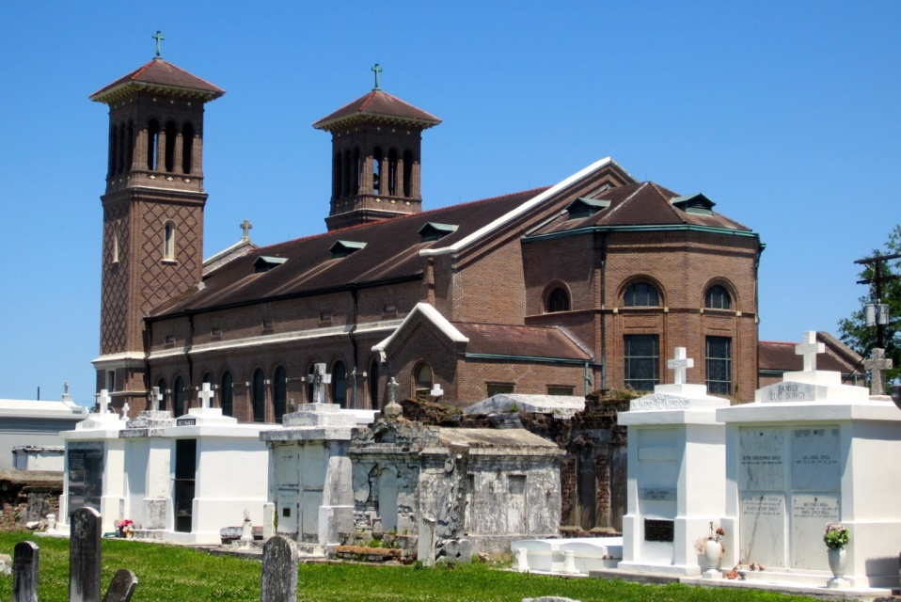

Joseph (String of Pearl) Bovie a native of Edgard, LA., passed away on Sunday, January 29, 2017, age 87, at Ochsner Medical Center Westbank. Son of the late Seraphin and Ophelia W. Bovie of Edgard; Husband of Helen Bovie; Father of Gregory(Rita) Campbell, the late Allen and Avis Bovie. Stepfather of Lawanda Blackmon and Luke(Ventura) O'Neal Jr. Grandfather of Arron(Keri), Christy, Ramona, Nikia, Luke Warren III, Larry Jr and 14 great grandchildren. Brother of Eula Bovie Mitchell. Devoted cousin of Coralee Songy and Melvin Bovie, a host of nieces, nephews, cousins, other relatives and friends. He was a Veteran of the US Army and retired from Thigpen Construction Co. Family, friends, and parishioners of St John the Baptist Parish Catholic Church, employees of Thigpen Construction, Intralox, Ochsner Hospital, Baumer Foods Inc. West Jefferson Hospital, Veolia, and East Jefferson Hospital are invited to attend a Mass of Christian Burial on Saturday, February 11, 2017 from St John the Baptist Catholic Church, 2361 Hwy 18, Edgard, Louisiana at 11:00 AM. Visitation will begin at 9:00 AM; Rosary at 9:30 AM; Entombment church mausoleum.   
 His final care has been entrusted to Treasures of Life-Center for Life Funeral Services, 315 E. Airline Hwy, Gramercy, Louisiana. 225.258.4039.

www.treasurefunerals.com (accessed 10/18/2018)