Joyce Marie (Lumar) Brown

January 27, 1959 – July 3, 2016

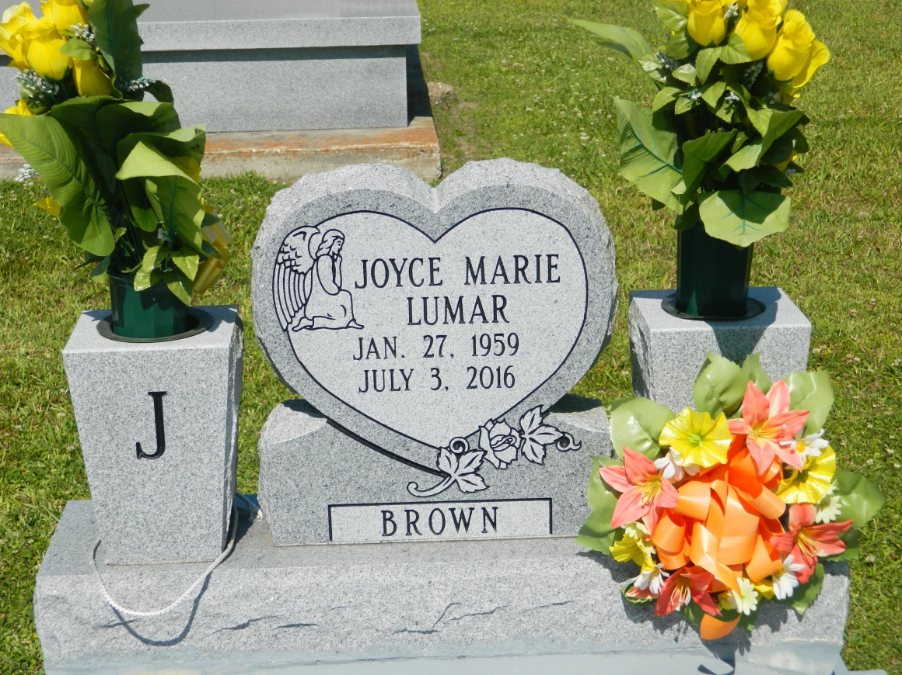

Joyce Marie Brown was called home to be with the Lord surrounded by family and friends on Sunday, July 3, 2016 at 4:00 P.M. A native of Edgard, La and a resident of Gramercy, La. Daughter of Philomena Lumar and the late Lawrence Patty Lumar. Mother of Devon, Kenya, and Jaiya Lumar; grandmother of Ma'kalia and Micah Bright, Mekhi Gordon and the late Kalia Bright; sister of Pamela (Norvan) Smith, Barbara Williams, Monica (Alfred) Hogan, Rojanne (Harvey) Tilton, Calvin (Brenda) Lumar , Carl (Renee) Lumar, Erin (Glanice) and Mark Lumar. Devoted godmother of Aaron Lumar and friend Ronald Griffin. She is also survived by a host of other relatives and friends. Employees of St. John the Baptist Parish School System, St. John the Baptist Catholic Church family, West St. John Class of "1977, Med-Pro Pharmacy, especially Dr. Cyrena Brown for her outstanding care shown throughout her time of illness and Occidental Chemical Plant are invited to attend a mass of Christian burial on Saturday, July 9, 2016 for 11:00 A.M. at St. John the Baptist Catholic Church, 2349 LA. Hwy. 18 Edgard, La. Father Robustiano Morgia celebrant. Interment church cemetery. Visitation begins at 9 A.M. Treasures of Life-Center for Life Funeral Services are entrusted with the arrangements of her final care. "When someone you love becomes a memory that memory becomes a TREASURE"

Times-Picayune, The (New Orleans, LA) - Wednesday, July 6, 2016

Contributed by Jane Edson