Alice Rita (Alfred) Burham

October 16, 1919 – September 24, 2003

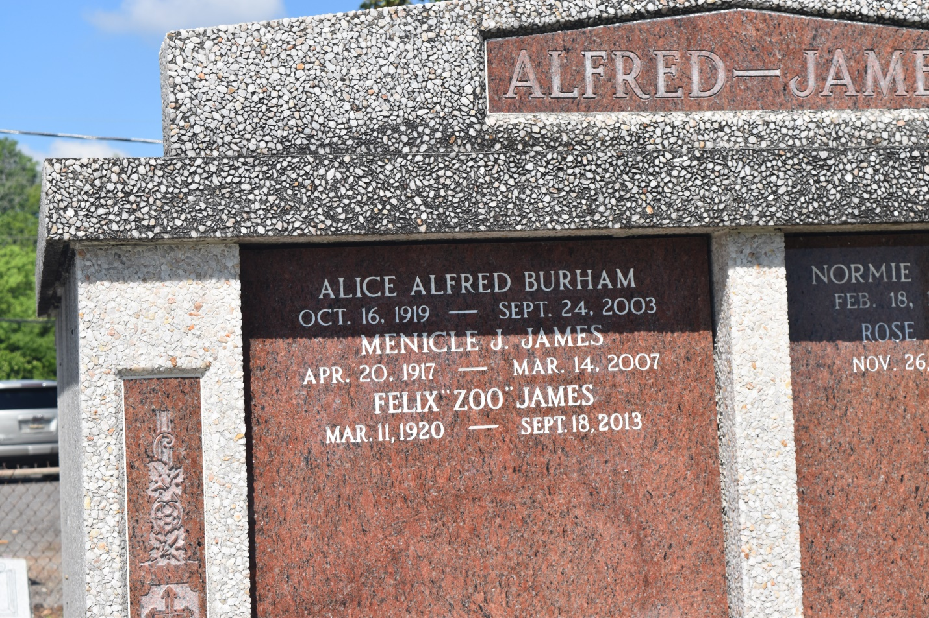

Ms. Alice Rita Alfred Burham died September 24, 2003 at Memorial Medical Center of heart failure. She was 83 years old. Ms. Burham was born in Edgard, LA. on October 16, 1919 to the late Fergus and Clarice Chaligny Alfred. She lived most of her adult life in New Orleans. She was a retired chandelier draper for Royal Company Antiques. Ms. Burham is survived by two sisters-Camille Weber and Bonita James, a brother-in-law, Felix "Zoo" James, two nieces-Bonita Bazil and Paula Miller of Detroit, MI, two nephews-Kenneth James and John Bossier of Memphis, TN, Godchildren: Evelyn Hunter of Boutte, LA. and Michael Roussell of Edgard, LA., five great-nieces, one great-nephew and a host of cousins and friends.  
  
A mass will be held Tuesday, September 30, 2003 at St. John the Baptist Catholic Church in Edgard, LA. Visitation at 10:00 a.m. Interment in the church's cemetery. Majestic Funeral Home in charge of arrangements. Jack Barrow & J.V. Haydel, Directors.

Times-Picayune, The (New Orleans, LA) - Monday, September 29, 2003

Contributed by Jane Edson