Theodore Burke

April 12, 1917 – May 16, 2006

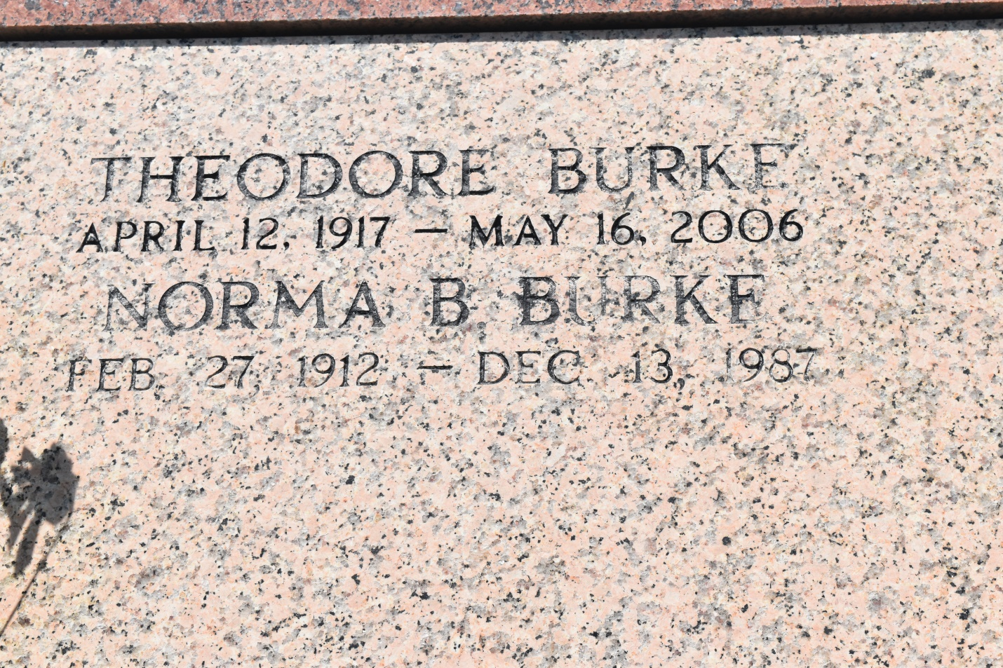

LUCY - Theodore Burke, 89, a native and resident of Lucy, died May 16. He was the husband of the late Norma Barre Burke.  
  
He is survived by his daughter Penny Goudia.  
  
He is also survived by a sister Annetta Burke Pierre, grandchildren Chenell (Damion) Brown, Felton Goudia Jr. and Anthony Goudia and brothers-in-law Odell Barre and Harold Merrick.  
  
He was preceded in death by his parents Zelma and Charles Burke Sr. and siblings Irvin, Cleveland, Albert, Charles Jr., Bertha, Angelina and Alma Burke.  
  
Services were held May 19 at St. John the Baptist Catholic Church, Edgard, with interment in the church cemetery.

L'Observateur (La Place, LA) - Monday, May 22, 2006

Contributed by Jane Edson