Sharey (Ethridge) Caire

September 4, 1929 - June 13, 2019

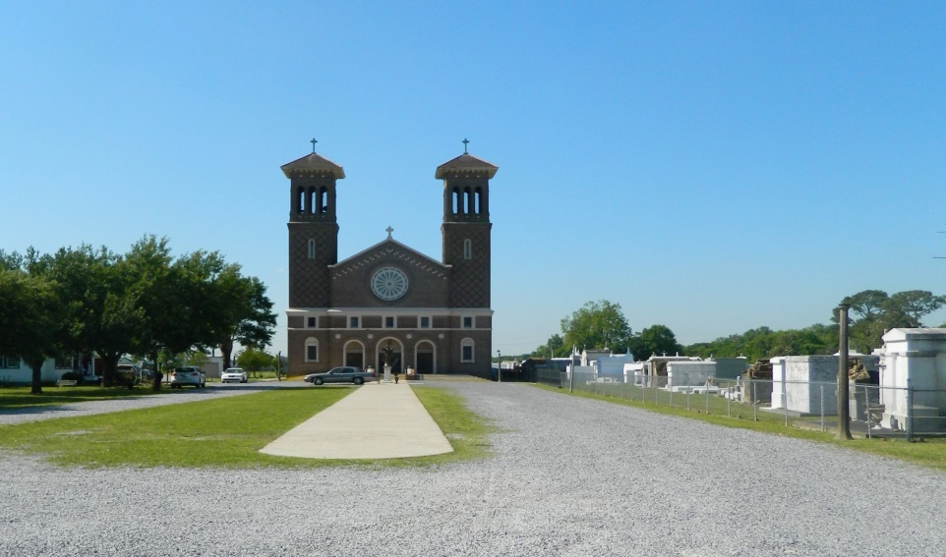

Sharey Ethridge Caire passed away on Thursday, June 13, 2019 at the age of 89. Sharey was born in Shreveport, LA, on September 4, 1929. She met her husband, Joseph, while studying at LSU, they married in 1950 and settled in Edgard, LA. Sharey obtained a graduate degree from Nicholls State University and taught high school chemistry and biology for 30 years. She was awarded the Most Outstanding Biology Teacher in the State of Louisiana in 1987. Sharey Caire is one of the most beloved teachers who has ever scratched a piece of chalk on a River Parishes blackboard. She has taught at Edgard High School, Hahnville High School, De La Salle High School, St. James Major, and Grace King High School, instilling not just the facts of science that would help them propel toward careers, but also a love of learning.

Beloved wife of the late Joseph Gregoire Caire. Loving mother of Terry Powell (Dap), Randy Caire (Debbie), Ginny Baranovic (Mike), Ruth Chapin (Mark), Joe Caire (Eva), Linda Hargrove (Brian) and the late Bill “Truman” Caire (the late Linda McCormick). Grandmother of Leigh Juday (Reid), Jacob Powell (Christina), Allison Aucoin (Christian), Benjamin Caire (Lindsey), Jeanne Amadon (John), Michael and Stephanie Baranovic, Seth and Matthew Chapin, Ellen, Cecilia and Sally Caire, Lois, Faith, Mac and Mary Claire Hargrove. Great-grandmother of Pascal, Beatrice and Julia Aucoin, Joe and Ezra Caire, Agnes and Edith Amadon. Only daughter of the late Randle Ethridge and Dorothy Parsons Ethridge.

Relatives and friends are invited to attend the Funeral Mass at St. John the Baptist Catholic Church, 2349 Hwy 18. Edgard on Tuesday, June 18, 2019 at 11:00 a.m. Visitation at the church from 8:00 a.m. until 11:00 a.m. Interment in St. John the Baptist Cemetery, Edgard. The family would like to express their heartfelt appreciation to the staff of Ashton Manor for their loving compassion and patience.

Millet-Guidry Funeral Home, LaPlace, LA (accessed 6/15/2019)