Julius A. Cannon Jr.

June 15, 1939 – May 5, 2000

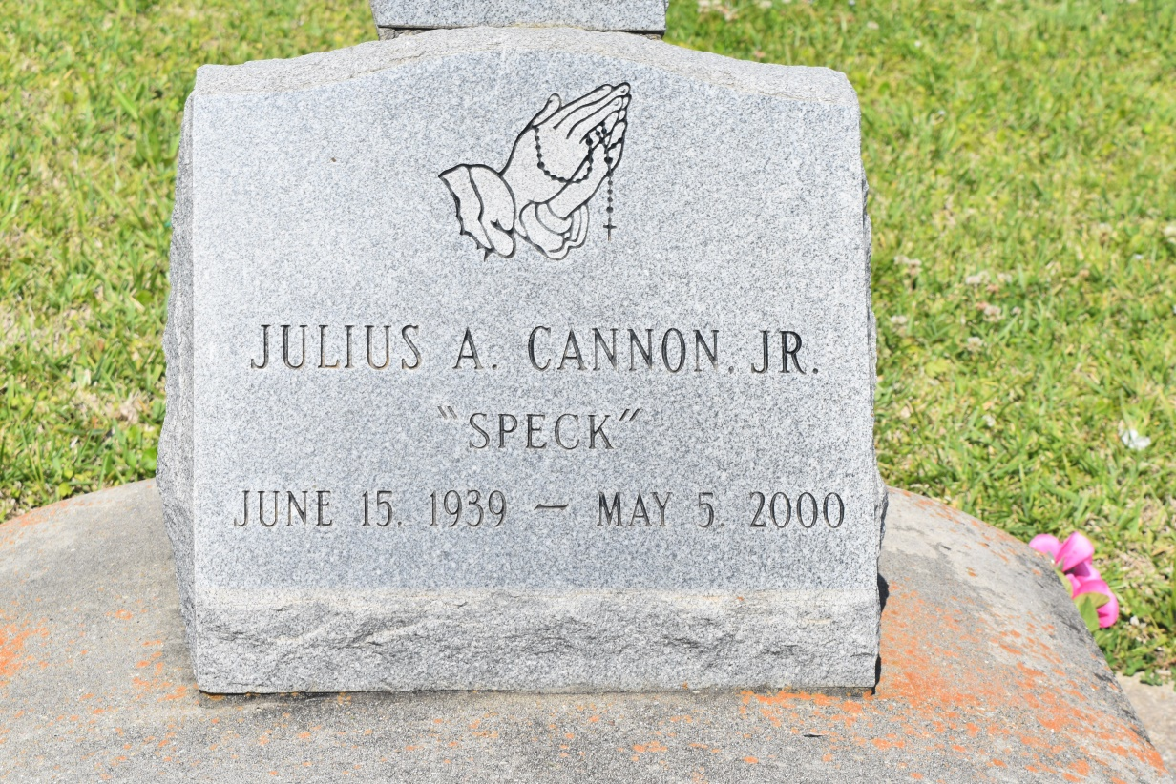

Julius Cannon Jr., a retired body and fender repairman, died Friday of lung cancer at St. Charles Parish Hospital in Luling. He was 60. Mr. Cannon was born in Lucy and lived in Hahnville for 22 years. Survivors include his wife, Emelda LaGrange Cannon; four sons, Anthony Cannon Sr. of LaPlace, Reginald and Roshon Cannon of Hahnville and Julius Cannon III of New Orleans; two daughters, Tanya Harris of Raceland and Kadoma Cannon of New Orleans; and eight grandchildren.

A Mass will be said Wednesday at 10 a.m. at St. John the Baptist Catholic Church on River Road in Edgard. Visitation will begin Wednesday at 8:30 a.m. Burial will be in the church's cemetery. Robottom Mortuary is in charge of the arrangements.

Times-Picayune, The (New Orleans, LA) - Tuesday, May 9, 2000

Contributed by Jane Edson