Jacques Cantrelle II

April 1, 1752 – September 12, 1824

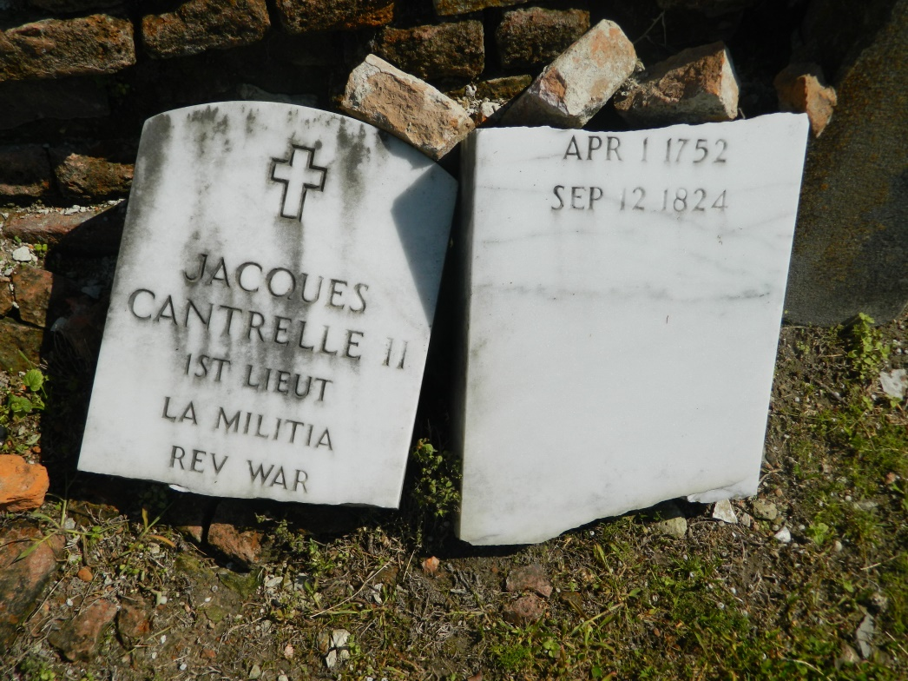

ANOSR Vol 16 (1824-1825) pg 68: CANTRELLE [@CANTREL], Jacques, native of St. James Parish, widower of Louise PICOU, age 67 years, interred on 12 September 1824, died 12 September 1824, at the residence of Dr. DESTEZ, resident of this parish (SJBED, F2, 86)

His Wife: ANOSR Vol 2 pg 227: PICOU [@PIQUOU], Marie Louise (Nicolas & Margueritte LAVIGNE) bt. 9 Jan. 1761, bn. 4 Jan. 1761, spo. Pierre ZERINGUE & Louise PICOU (SLC, B4, 45)

ANOSR Vol 12 pg 305: PICU, Luisa (Nicolas & Margarita LAVIGNE), native of St. Charles Parish on the first German Coast, resident of this city, spouse of Santiago [my note: Spanish for Jacques] CANTRELLE, 55 years of age, interred on 30 September 1817 (SLC, F11, 80)

**ANOSR information thanks to Celeste Boudreaux Peters**

Siblings: Madeleine M / b.1730 Marie M. / 1733-1788 Marie Eva / 1734-1805 Marie Jeanne / 1736-1794 Jean Baptiste / b.1744 Michel B. / 1750-1814

Children: Jacques N. III / 1779-1831 Jean Baptiste / 1780-1808 Valerin / 1780-1802 Louise / b.1782 Melita / 1782-1832 Casimire L. / 1784-1812 Celesie A. / 1785-1819 Casimiro / b.1787 Hermogene / 1794-1863 (my 4xGGF) Magdalena D / 1796-1818 Luisa / b.1799 Eugenia B. / b.1801 Marie Celeste / 1803-1823

**Sibling and children information thanks to Sandra Schott**