Gail Marie (Cox) Ceaser

October 4, 1959 - February 8, 2022

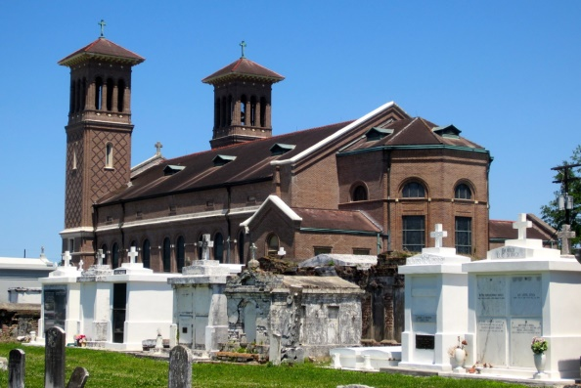

On February 8, 2022, Gail Marie Cox Ceaser was ushered into the arms of our triune God and received with joy by the angels and each of our precious loved ones who transitioned before her.  Although we were sad to see her leave, they were indeed glad to see her come. Gail, or “Black”, as our daddy affectionately called her, was born to Milton Charles Cox, Jr. and Dolores Hilaire Cox on October 4, 1959, in New Orleans, Louisiana.

Gail grew up in Edgard, Louisiana, the oldest of eleven children.  Whenever we would gather, Gail would tell the funniest stories about being the oldest child in such a large family.  We would playfully tease her about throwing us out to clean the house the second momma would leave. She would laugh and point out that all of her hard work didn't last for long.  Because there were so many of us, we would rapidly undo most of the work she had done.  We definitely got on her nerves, but she loved us.

Gail was the person who consistently checked in on everyone, ready to offer an encouraging word, timeless wisdom and, of course, powerful prayers. One of the last text messages encouraged us not to be discouraged.  In Gail's words, “Family, I’m sending this message to you because GOD said someone is feeling discouraged.  He wants us to trust in Him, to wait on Him.  If you are feeling discouraged, please know that GOD is on your side.  The plans you may have for you or your family is never greater than what GOD has for them.  GOD is working it all out for our good.”  Love was the constant refrain in Gail’s heart.  This was our Gail Marie, a soul through whom God accomplished wondrous things because her tender heart was always willing to receive Him.

Gail flew the coop and set out on her own at the tender age of nineteen to begin a new life and career. Gail eventually married the love of her life, Ernest Charles “Sonny” Ceaser on December 29, 1991.  This divine match produced the second greatest love of Gail’s life, her daughter, Meagan Michelle Ceaser.  Gail was also a loving “bonus mom” to Latonia Adams, Crystal Ceaser Westmoreland and Lance Lyons. Gail worked as an Administrative Analyst IV for Entergy New Orleans, retiring after 35+ years of dedicated service.  After retirement, Gail loved spending quality time with her husband, family, and her devoted friends.  She adored Sonny and relished quiet mornings with him at the kitchen table, enjoying warm conversations over many cups of hot coffee.  Gail also fiercely loved Meagan, dutifully and lovingly guiding her precious daughter through the different seasons of her life.

She was also an avid reader who loved photography, writing, studying the Word of God, ministry and especially being “Granny” to her two youngest grandchildren, Micah and Eden. As much as Gail loved her family, she would come alive when she shared the Word of God.  Hers was a heart totally surrendered to God. In the last two years of her life, Gail dedicated one hour, nearly every Wednesday night, to leading our weekly family bible study.  She also enjoyed sharing God’s love and wisdom in her blogs - Morning Glory and What is Your Truth?  We’ve shared Gail's final blog with you, which was about prevailing and trusting God through difficult times.

<https://mondaymorningglory.wordpress.com/2022/01/> This was Gail’s way, gently inviting others to accept Christ as their Savior or to pursue a deeper relationship with God.

There’s so much more we could share about Gail, but if we had to pick one word to describe her, it is LOVE.  Although her name means joy in Hebrew, Gail was God’s love personified.  And, through her life, God brought so much joy into the world.  Her warm, welcoming presence was a blessing to everyone.  Gail made you feel seen, and her home overflowed with God’s love and Presence.  Her home was a safe place, where we knew Gail would hold us tight, patch our wounds and fill our hearts with the peace of God’s word. She constantly told us that we could not do anything apart from God.  Her faith was steadfast and immovable. Gail once declared that she was the watchman over our family on earth.  Today, she watches over us with all the angels, seated with Christ in heavenly places, among the cloud of witnesses. It is our family's prayer that Gail’s life draws you closer to God.  Through her life may you know today that God loves you, He sees you and He surrounds you every single day.

Gail was preceded in death by her paternal grandparents, Milton Charles Cox, Sr. and Thelma Cox, her maternal grandparents, Romuald Hilaire and Noelie Hilarie Smith, her aunts, Mildred Cox White, Audry Hilaire Oubre, Eldoris Cox Adams, Marsha Cox Johnson and Enola Cox, her uncle Betrand James Hilaire, Sr., her cousin-in-law, Judy Mathis Johnson, and her beloved nephew Terrence Michael Bethancourt.

She leaves a large, loving family behind to carry on her beautiful legacy including her husband, Ernest Charles Ceaser, her children, Meagan Michelle Ceaser, Crystal (Gerald) Westmoreland, Latonia Adams, and Lance Lyons; her parents Milton Charles Cox, Jr and Dolores Hilaire Cox, her sisters and brothers, Keith (Trinese) Cox, Milton Charles Cox III, Darlene (Cecil) Bethancourt, Bryant (Michelle) Cox, Rodney (Nicol) Cox, Mark (Charlene) Cox, Tina (Raffeal) Neal, Marlet Cox Becnel, Kimberely (Steven) Arcenaux and Denise (Brent) Cox, her grandchildren, Micah Gauthier, Eden Rose Gauthier, Dontrelle Baldwin, Kyeria Adams, Tessie, Talisa, Jada, Brooke and Ivy Westmoreland, great grandchildren, Adan, Lei’Lani and Arya, her goddaughter Asia Gabriel Arcenaux, a host of sister-in-laws, brother-in-laws, aunts, uncles, nieces, nephews, cousins and devoted friends.

Relatives and friends of the family are invited to attend the funeral services.  A Mass of Christian Burial honoring the life and legacy of the late Gail Marie Cox Ceaser will be held on Friday, February 25, 2022, at St. John the Baptist Catholic Church, 2361 Hwy 18, Edgard, LA at 10 a.m.  Rev. Robustiano Morgia, Officiating. In accordance with the CDC guidelines for COVID-19 all in attendance must wear a mask ad practice social distancing.  Visitation will begin at 8 a.m.  Rosary at 9 a.m.  Interment in St. John Mausoleum, Edgard, LA.  Professional service entrusted to Patrick Sanders Funeral Home.  605 Main Street, LaPlace, LA  70068.  For information 985-359-1919.

The Patrick H. Sanders Funeral Home, LaPlace, Louisiana