Philip Eloi Chauvin, Sr.

October 11, 1899 – July 12, 1990

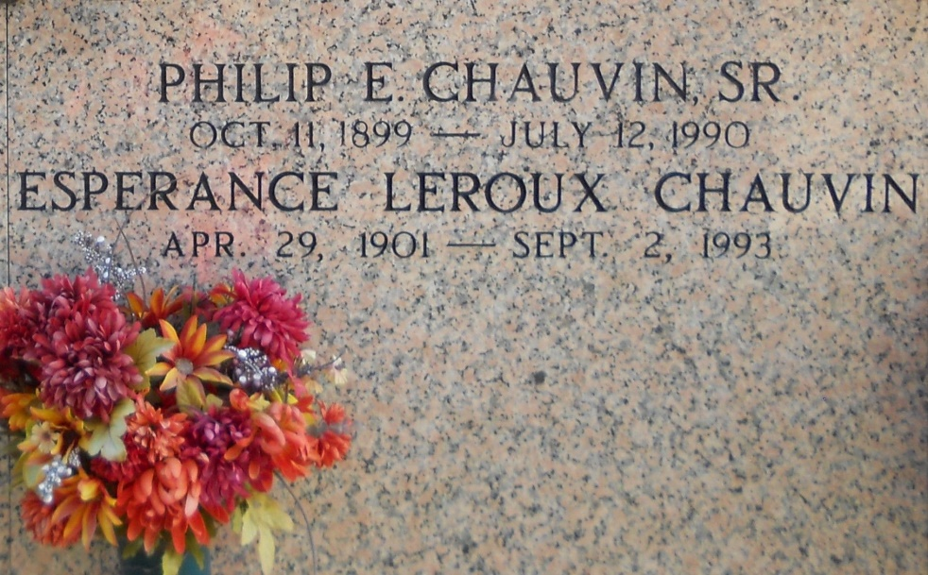

Photo by Team T Lo

Funeral services are scheduled at 10 a.m. Saturday at St. John the Baptist Catholic Church in Edgard for Philip E. Chauvin, 90, a native of Chauvin and resident of Edgard who died Thursday at 10:15 a.m.Visitation is scheduled from 5-9 p.m. Friday and 8 a.m. until funeral time Saturday at the church. Interment will be in the church cemetery. He was the husband of Esperance L. Chauvin; father of Verline Pellegrin, Bertha deMarsche, Paulette Amedee, Eugene, Ivy, Raymond, Philip Jr., Ray and Myles Chauvin; and brother of Virgie C. Acy. He is also survived by 45 grandchildren and 76 great grandchildren. He was preceded in death by a daughter, Amelie C. Kaupp. Millet-Guidry Funeral Home, Laplace, is in charge of the arrangements.

The Lafourche Daily Comet, Thibodaux, LA; JUL 12 1990

Contributed by Chris Tidwell